**Key User Manual**

Oracle CPQ and Subscription Management Cloud

User Manual

*User Manual for Oracle CPQ and Subscription Management Cloud*

Author : Mastek

Creation Date : 24/07/2024

Last Updated :

Version : 1.0

1. DOCUMENT CONTROL 4

1.1. Change Record 4

1.2. Reviewers 4

2. How to Reset password of a user in CPQ? 5

3. How to Log In? 6

3. How to change Regional Settings? 7

4. How to View Quotes created via CRM systems (Salesforce/MS Dynamics)? 8

5. Manage Quotes (Oracle CPQ) 9

6. Manage Subscriptions (Oracle Subscription Management) 28

6.1 Creating Item/Product for Subscription and CPQ 28

6.1.1 Steps to create an Item 28

6.1.2 Adding the item/part in CPQ Pricing Database Table 35

6.2 Subscription Structure 38

6.2.1 Subscription Header 39

6.2.2 Subscription Products 39

6.2.3 Subscription Product Pricing 40

6.2.4 Subscription Product Billing Summary 41

6.3 Manage Subscription Actions 42

6.3.1 Email 42

6.3.2 Validate 43

6.3.3 Apply Hold 43

6.3.4 Duplicate Subscription 43

6.3.5 Send Bill Lines to Receivables 45

6.4 Understanding Subscription Profiles 47

6.5 Understanding Renewal Controls 50

# DOCUMENT CONTROL

## Change Record

| Date | Author | Version | Change Reference |
| --- | --- | --- | --- |
|  |  |  |  |
| 24/07/2024 | Sanket Kumar, Akhilesh Nathwani, Vasantha K | 1.0 | Document Creation |
|  |  |  |  |
|  |  |  |  |
|  |  |  |  |

## Reviewers

| Name | Position |
| --- | --- |
|  |  |
| Sanket Kumar | Mastek CPQ Lead |
| Harshad Makadia | Mastek CPQ-Subscription Solution Lead |
| Akhilesh Nathwani | Mastek CPQ-Subscription Solution Lead |
|  |  |
|  |  |
|  |  |

# 2. How to Reset password of a user in CPQ?

Sales Users need to reset the password.

1. Refer the email and follow the steps for reset the password.

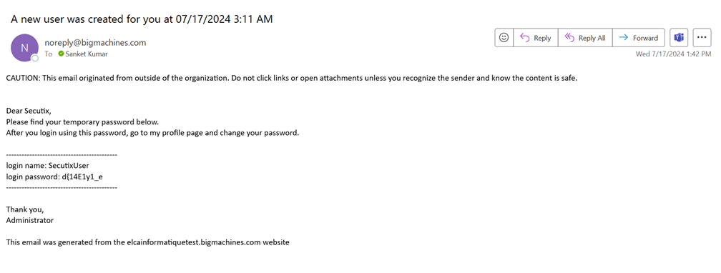

Go to My Profile

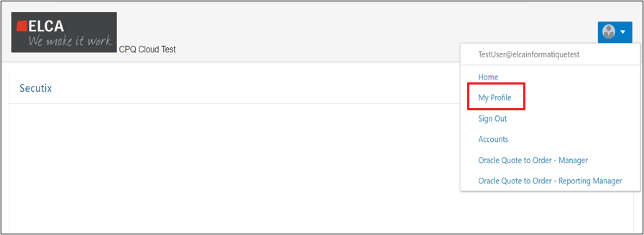

Update the password and Click on Change Password button

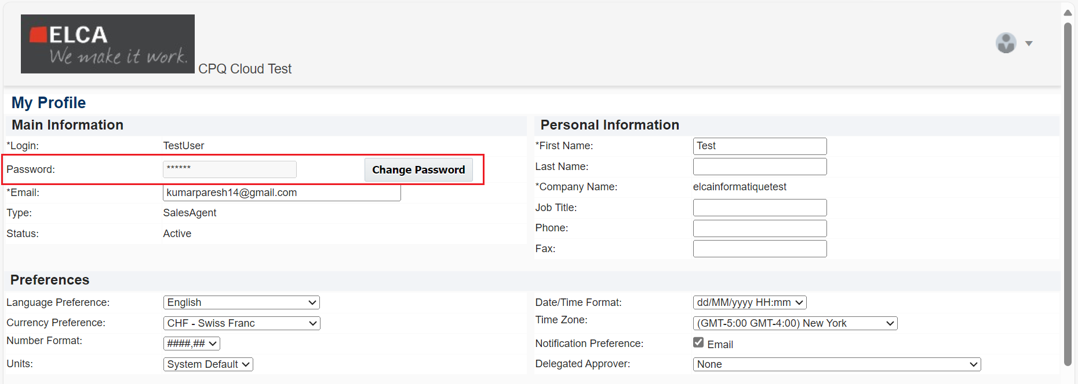

1. Sales users will receive an email that the password is changed.

# 3. How to Log In?

**CPQ**

This Section is for employees to login to CPQ.

1. Enter the URL in the browser. (URL: <https://elcainformatiquetest.bigmachines.com/> )
2. Enter your username and password.
3. **Click on Log In**.

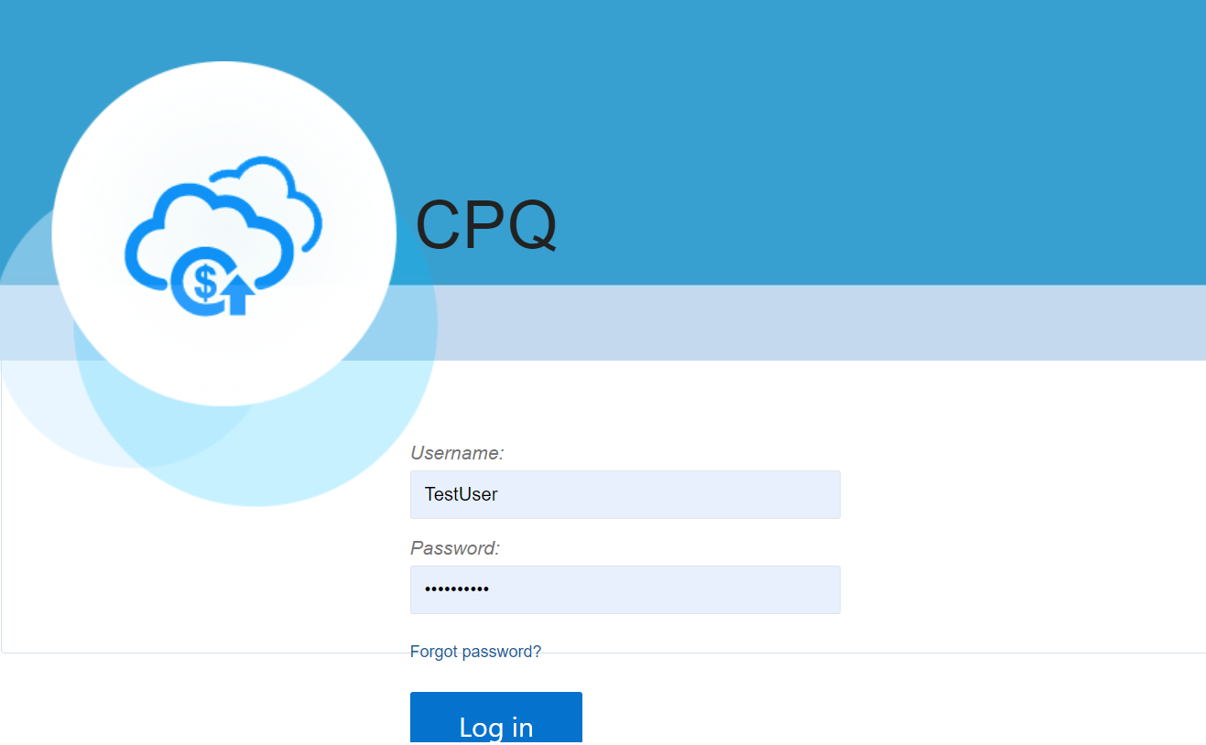

Subscription Management

1. Enter the following URL in the browser (<https://login-iaaras-test.fa.ocs.oraclecloud.com>)
2. Enter the username and password
3. Click on Sign In

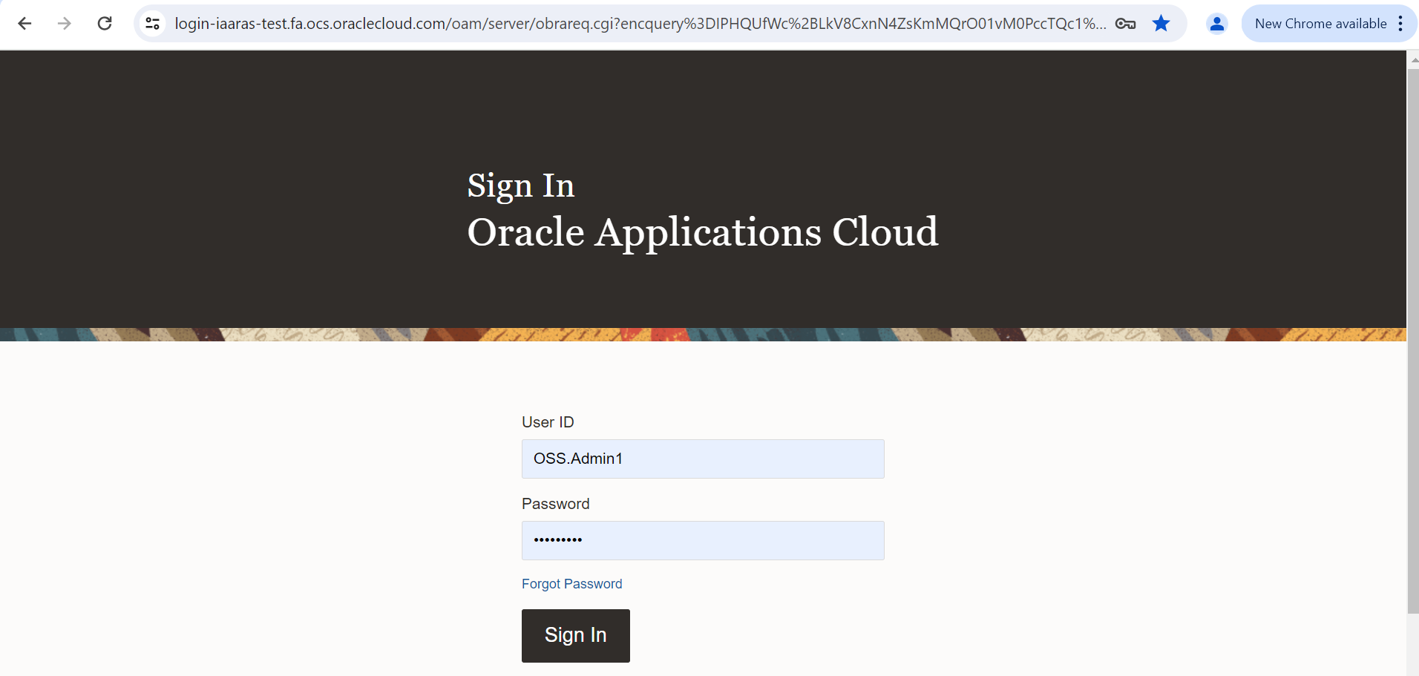

# 3. How to change Regional Settings?

When an Employee wants to change the date format, number format, time format and time zone, they should follow the below mentioned steps:

1. Navigate as follows*: Go to My Profile > Preferences section*

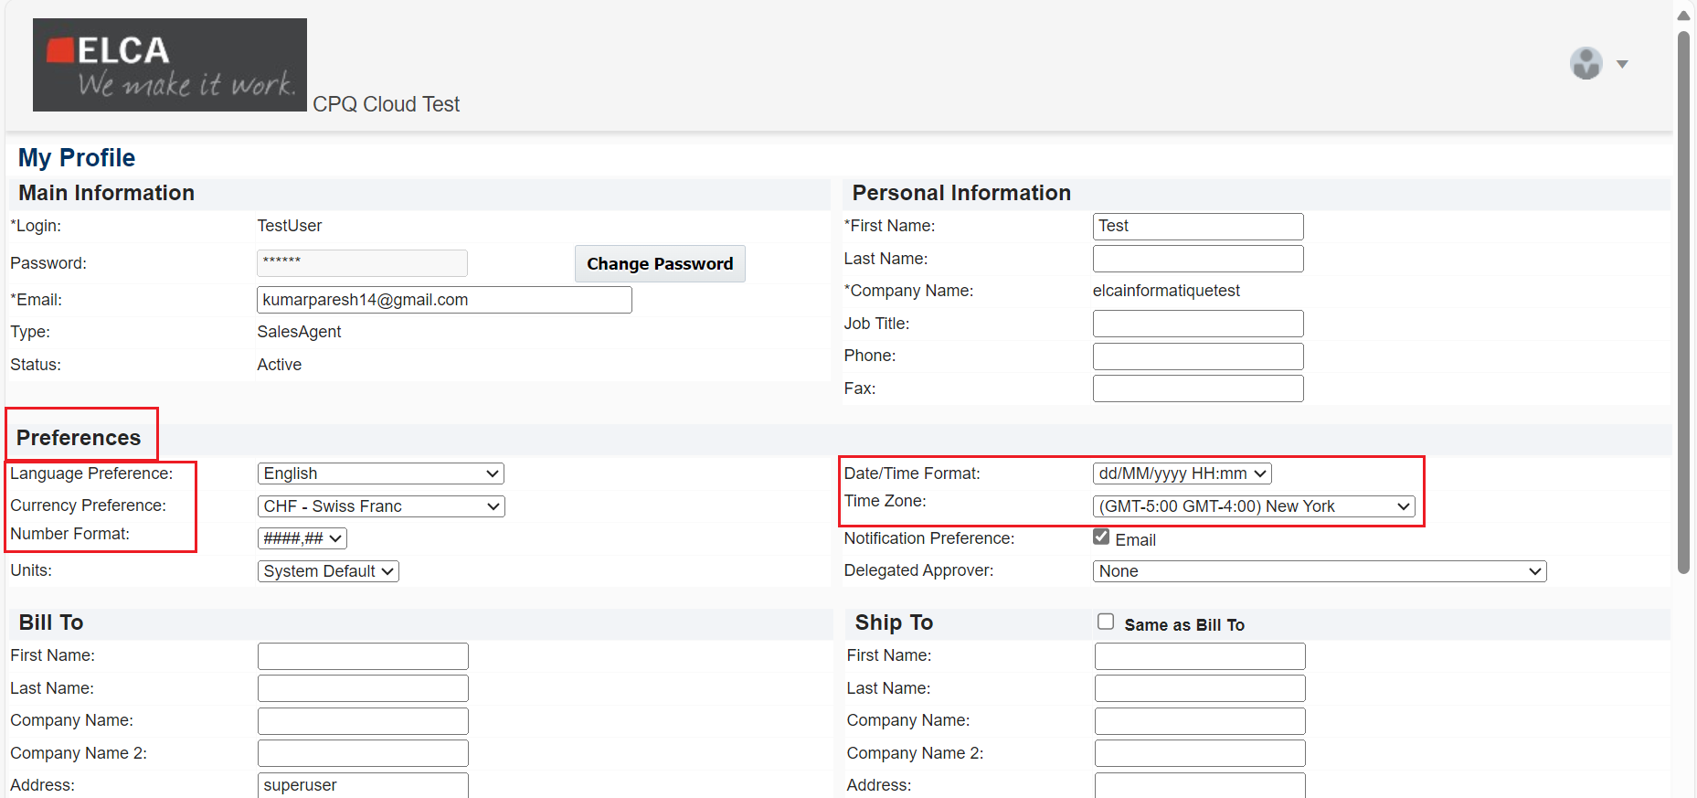

# 4. How to View Quotes created via CRM systems (Salesforce/MS Dynamics)?

This section shows you how to view all quotes created via CRM systems like Salesforce or MS Dynamics

1. Click on **Oracle Quote to Order - Manager** to view the quotes.

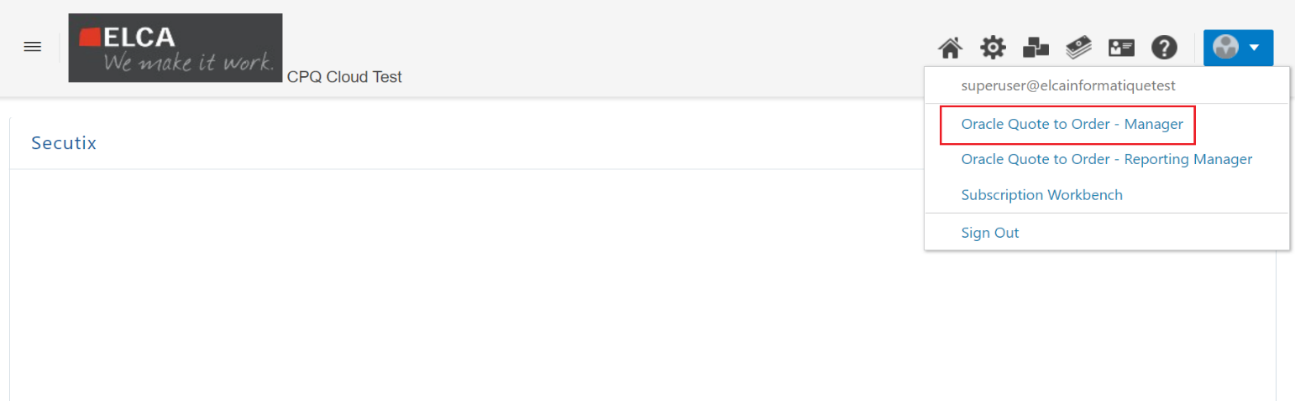

Yow will be able to see all quotes

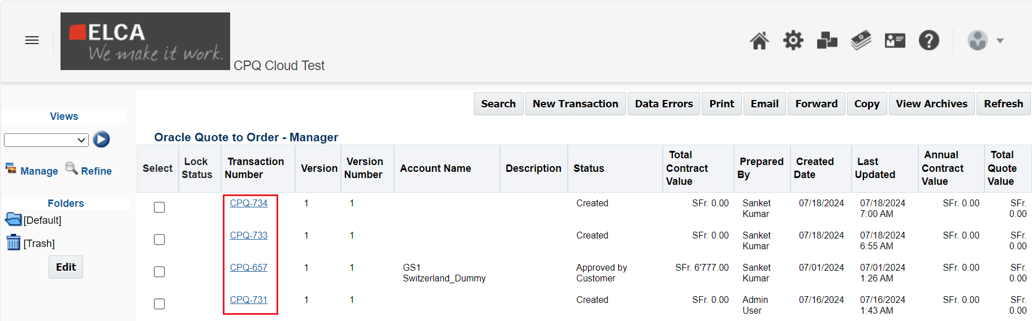

# 5. Manage Quotes (Oracle CPQ)

You can see multiple tabs below once you open the quote. Each tab contains attributes, actions and subtabs for different purposes.

* 1. **Quote Details tab:** This tab holds the basic details like Quote Name (auto generated), Quote Number (auto generated), Business Unit and Legal Entity (Sync from CRM system) etc.

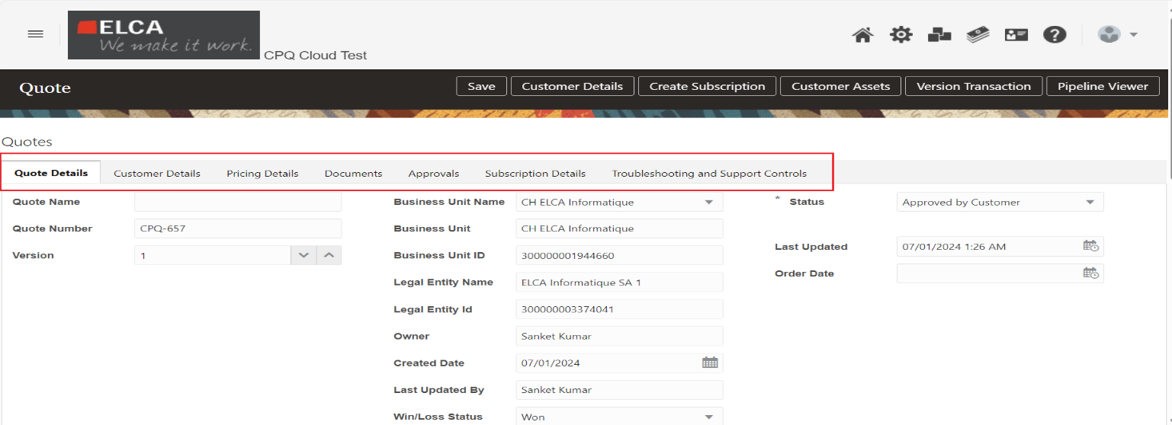

* 1. **Customer Details tab:** The sales users have below provisions in customer tab

1. Refresh Customer and Sites - To refresh customer and sites details via Refresh Address action from account and addresses data table. This action will be used when Opportunity is being sync from Salesforce/MS Dynamic system to CPQ quote.
2. Browse Customer - To browse and select customer and bill-to/ship-to sites via Browse action in this tab. This action can be used when you want to change customer and addresses for Quotes. Users can search any customer either with Customer Id or Customer Name. Copy the Customer ID from the Custom ID attribute on “Customer Details”. Paste the same after clicking “Browse”.

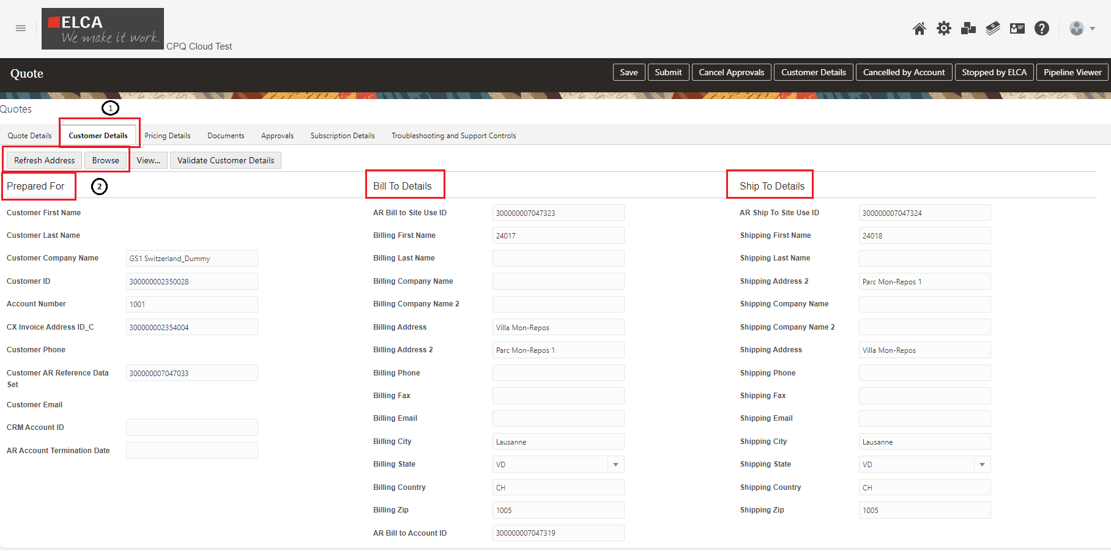

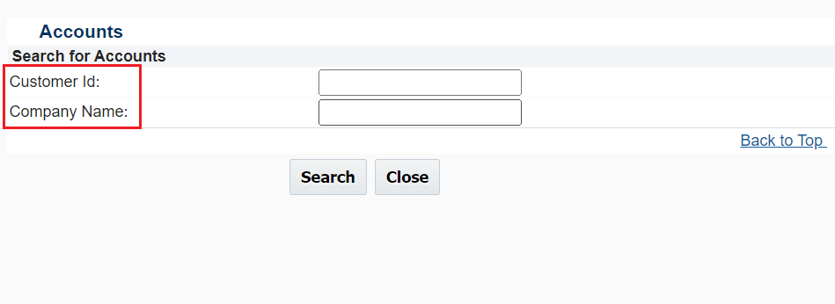

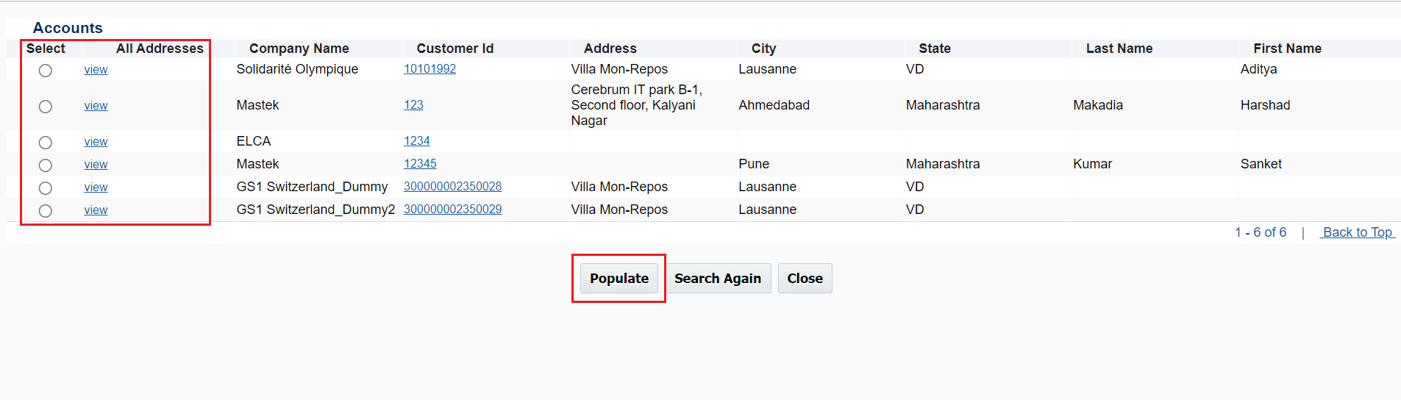

* 1. **Pricing Details:** The exchange rates can be setup for multiple currencies in this tab. The sales users can leverage this functionality to exchange the rates from CHF to any other currency as per business needs.

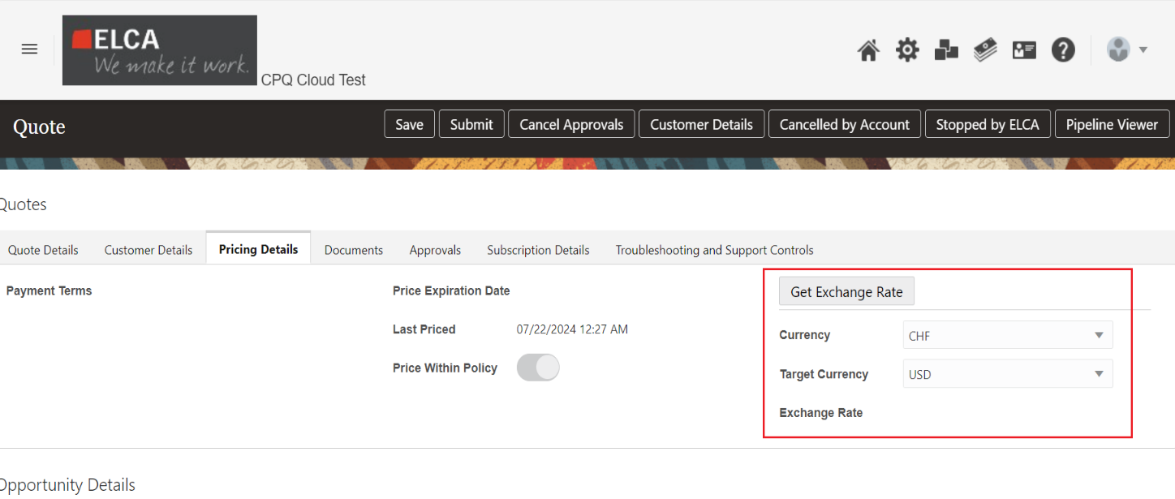

* 1. **Documents tab**: Once the Quote is created with the required information, the Sales user can select the desired Document Language from the Documents tab and generate the document accordingly.
* In below User can select the **Document Language** as English /French /German/Italian/Spanish/French as per the user specific languages.

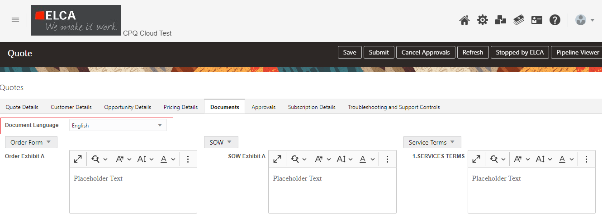

* The user input provided in the highlighted fields below will be automatically pulled into the Document Output Template.

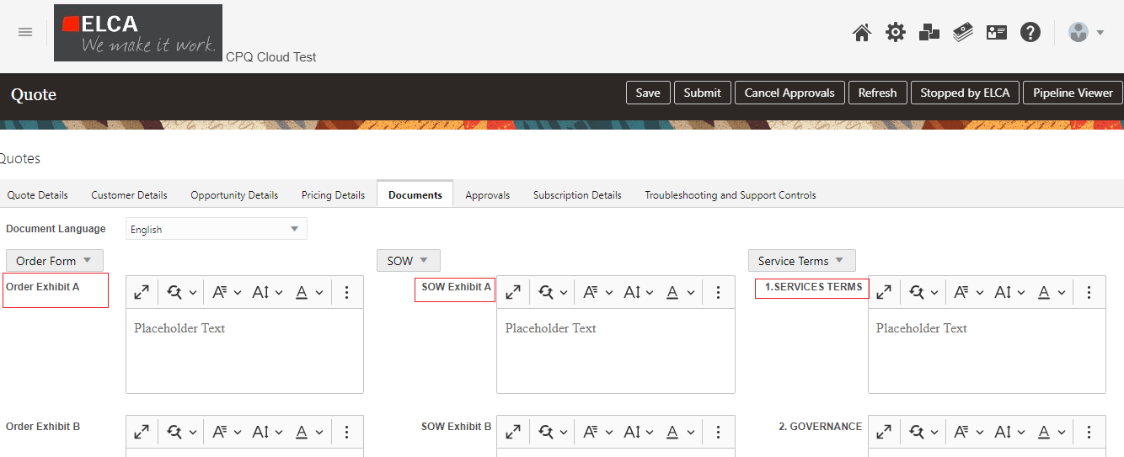

* For the SECUTIX Order Form, the following RTE (Rich Text Editor) attributes will be available for sales users to input data. This data will then be pulled into the Document Template

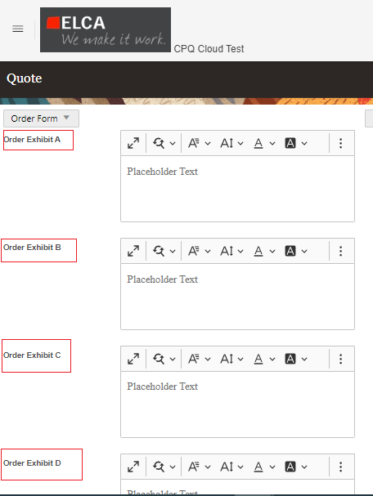

* Users can generate the SECUTIX Order by clicking on the highlighted “**Generate SECUTIX Order Form**”

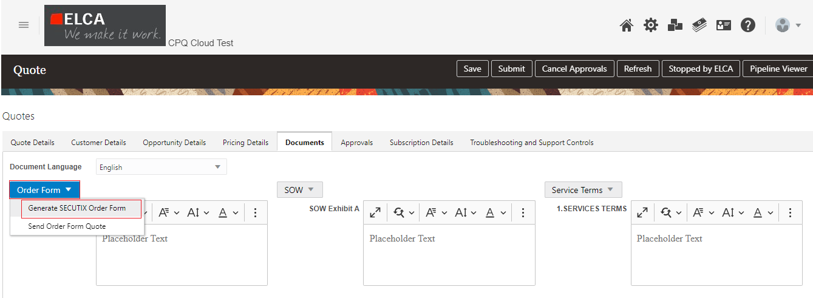

* For the SECUTIX SOW Form, the following RTE (Rich Text Editor) attributes will be available for sales users to input data. This data will then be pulled into the Document Template

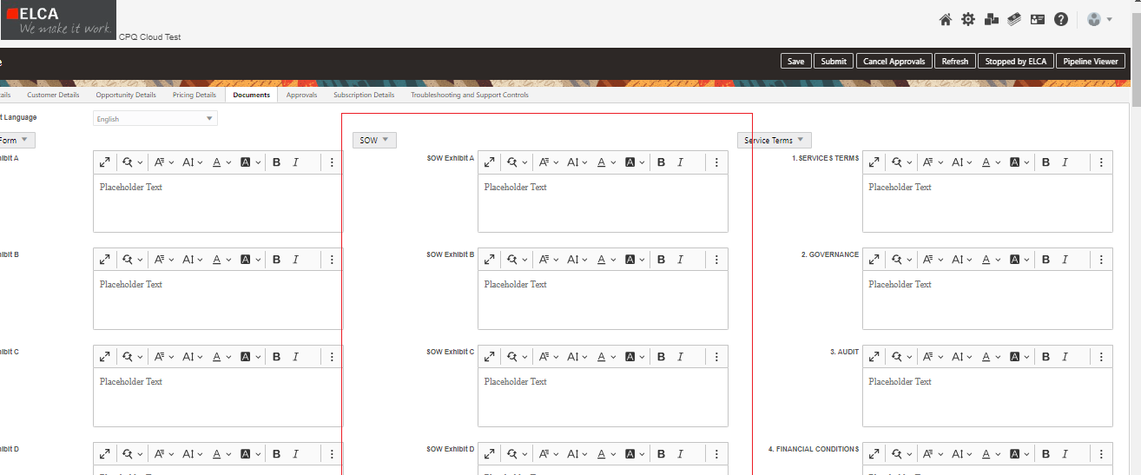

* Users can generate the SECUTIX SOW Document by clicking on the highlighted “**Generate SECUTIX SOW**”

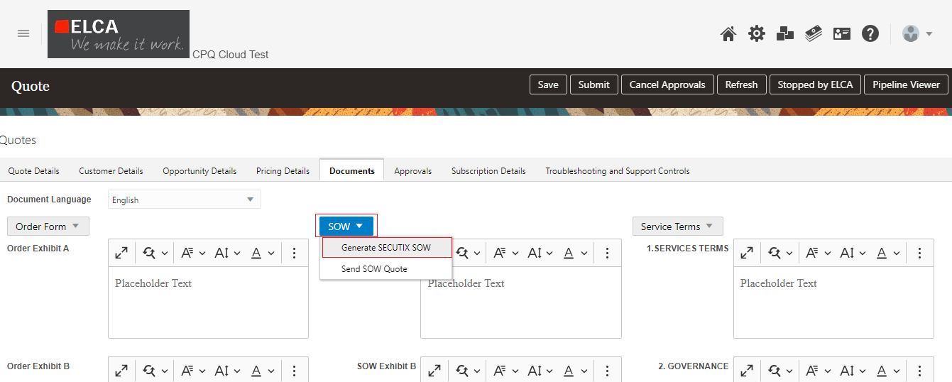

* For the Service Terms, the following RTE (Rich Text Editor) attributes will be available for sales users to input data. This data will then be pulled into the Document Template

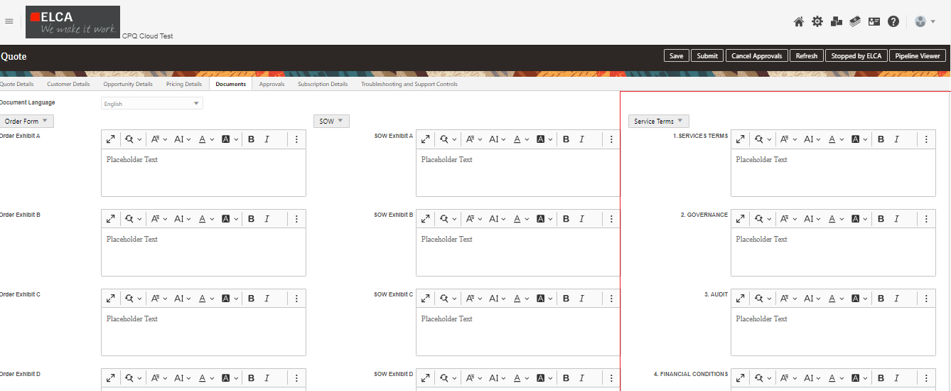

* Users can generate the Service Terms Document by clicking on the highlighted “Generate SECUTIX Service Terms”

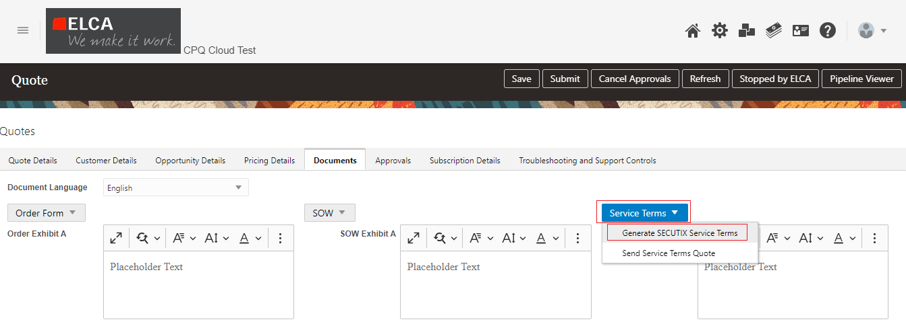

* Secutix Order Form Attachment will be generated automatically and add to the CPQ Quote. Please see below highlighted area to get the Form Attachment.

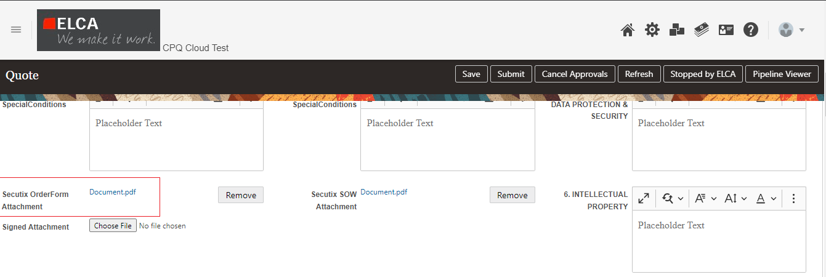

* Secutix SOW Attachment will be generated automatically and add to the CPQ Quote. Please see below highlighted area to get the Form Attachment.

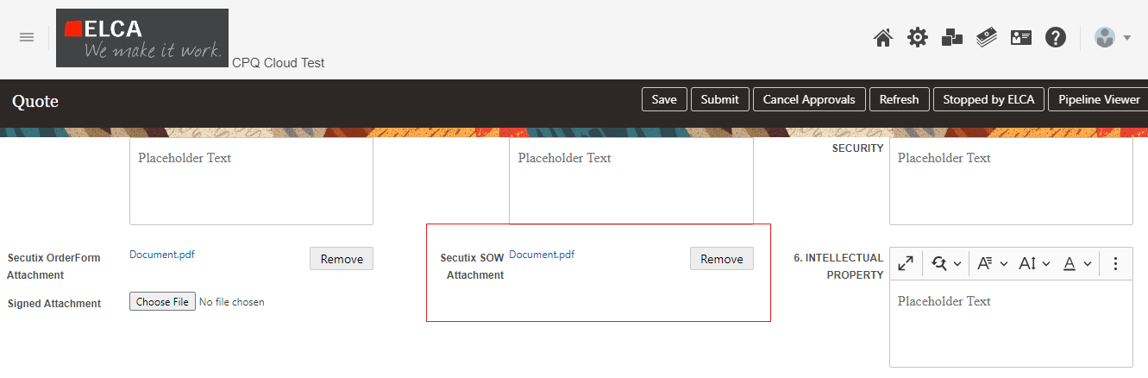

* Secutix Services Attachment will be generated automatically and add to the CPQ Quote. Please see below highlighted area to get the Form Attachment.

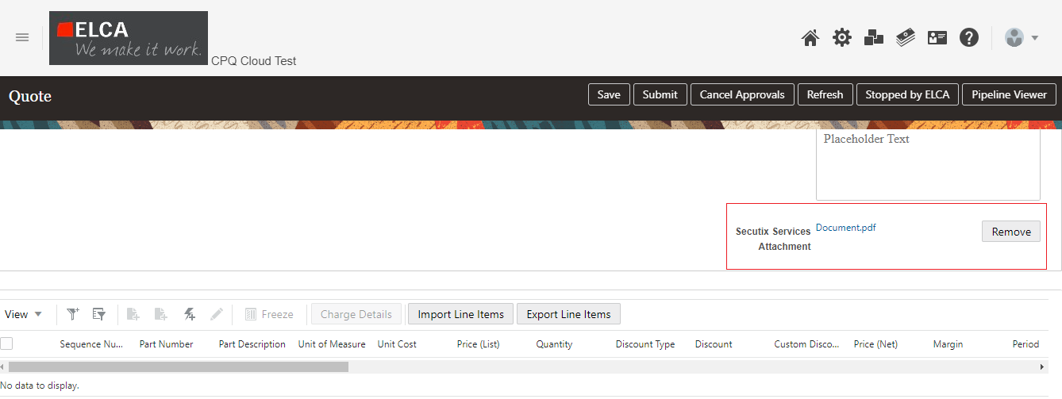

* Users can be able to send the Order Form by clicking on “Send Order Form Quote” to the Customer for the further process. Please see below.

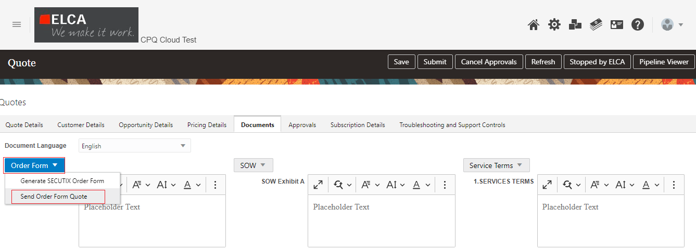

* Users can be able to send the SOW Form by clicking on “Send SOW Quote” to the Customer for the further process. Please see below.

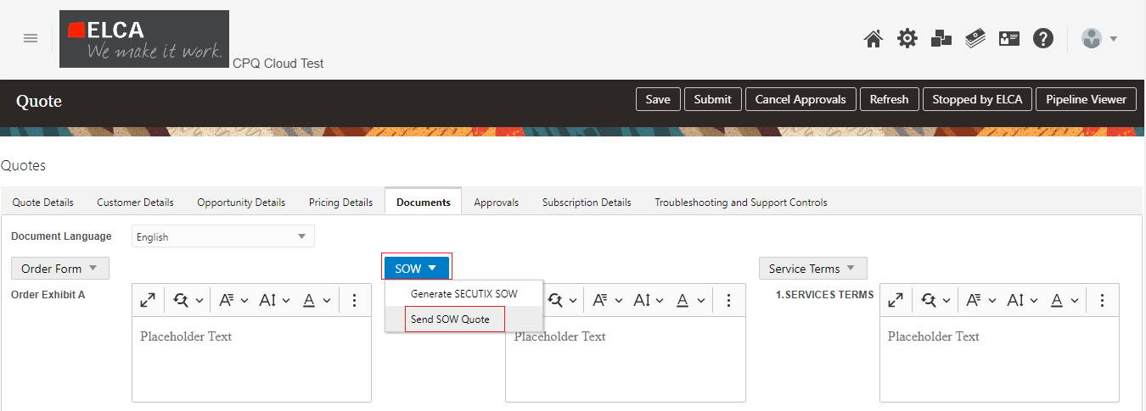

* Users can be able to send the Services Terms form by clicking on “Send Services Terms Quote”. to the Customer for the further process. Please see below.

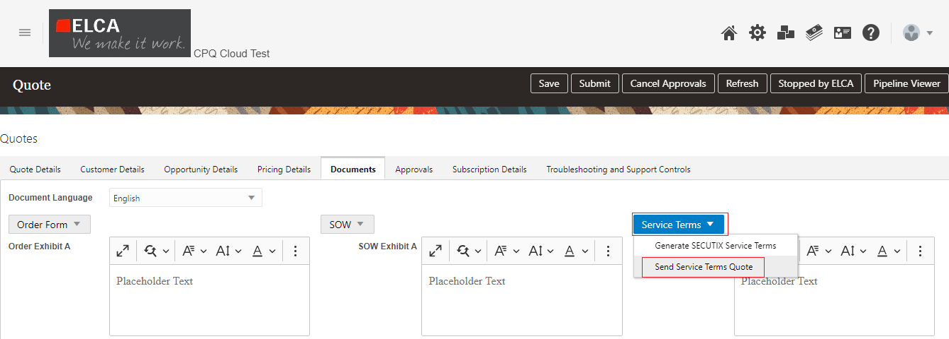

* Once the Sign-in process completed from Customer side, users can add the Signed attachment to the CPQ Quote. Please see below.

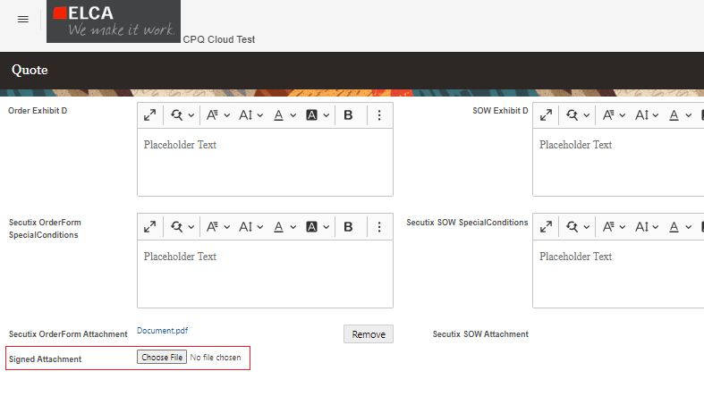

* 1. **Approvals tab:** Every quote will go through approval process once in their life cycle and need to be approved by internal team. The sales users can submit the quote for approval after putting all the details in it and submit it for approval and can see approvers details and approval history whom they submit the quote for the same.

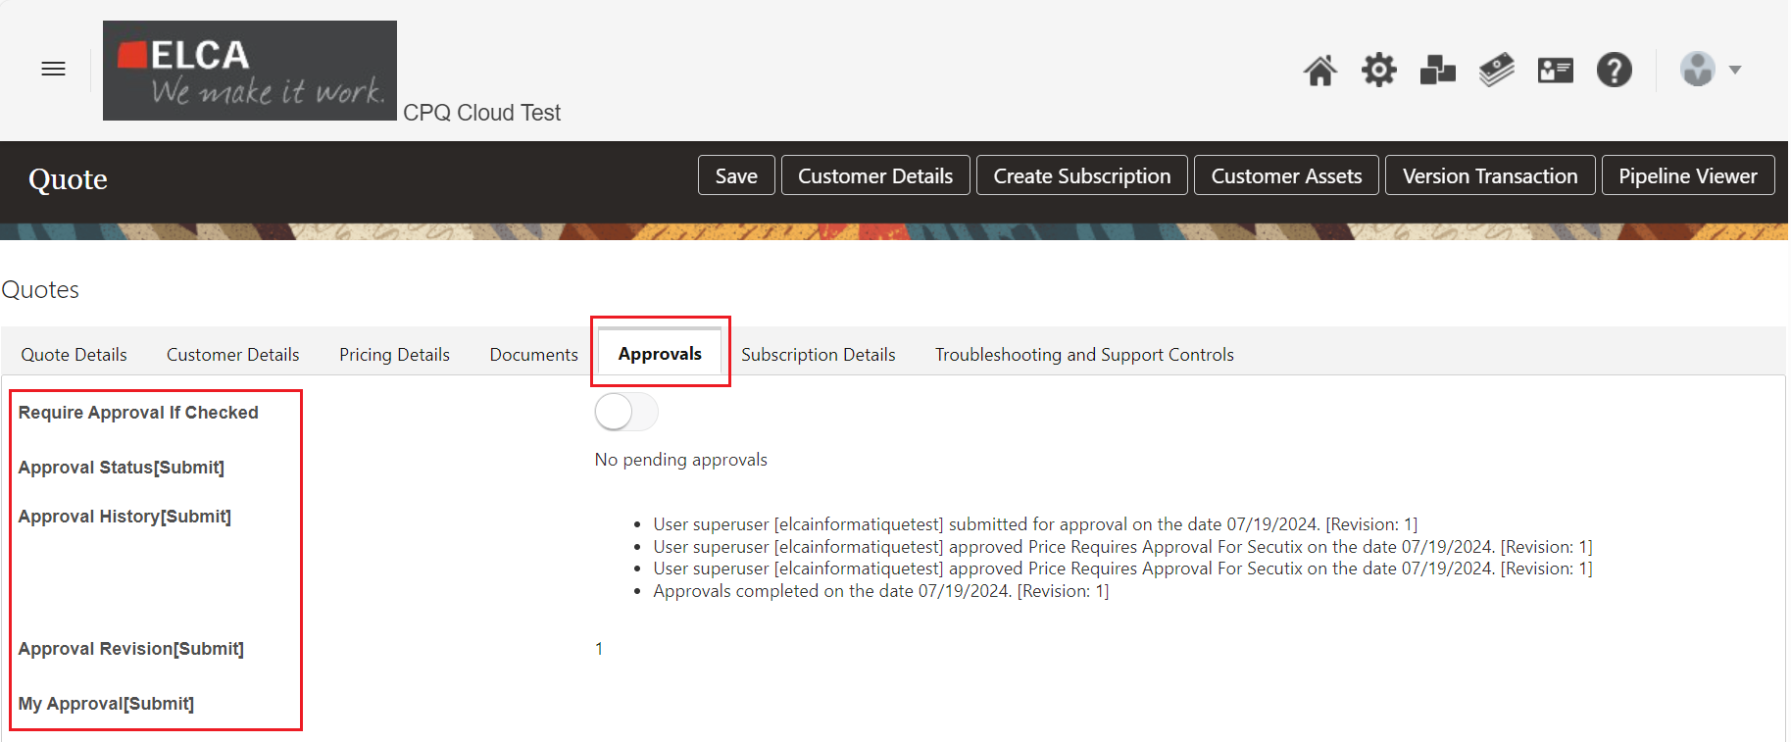

**5.6 Subscription Details:**

This tab consists of entire process of subscriptions e.g. Creation of subscription, Amendment, Renewal and Termination of subscription in CPQ. The sales users can leverage functionality to create subscription by filling all necessary details for the subscription products and proceed for the internal approval and customer sign off and submit it for subscription creation in Subscription Management.

**5.6.1 Subscription Creation:** The sales users can submit the quote for subscription creation in Subscription Management once it is signed by customer. Follow the below step by step process to create subscription.

1. **Quote Details:** Update below necessary subscription details in Quote

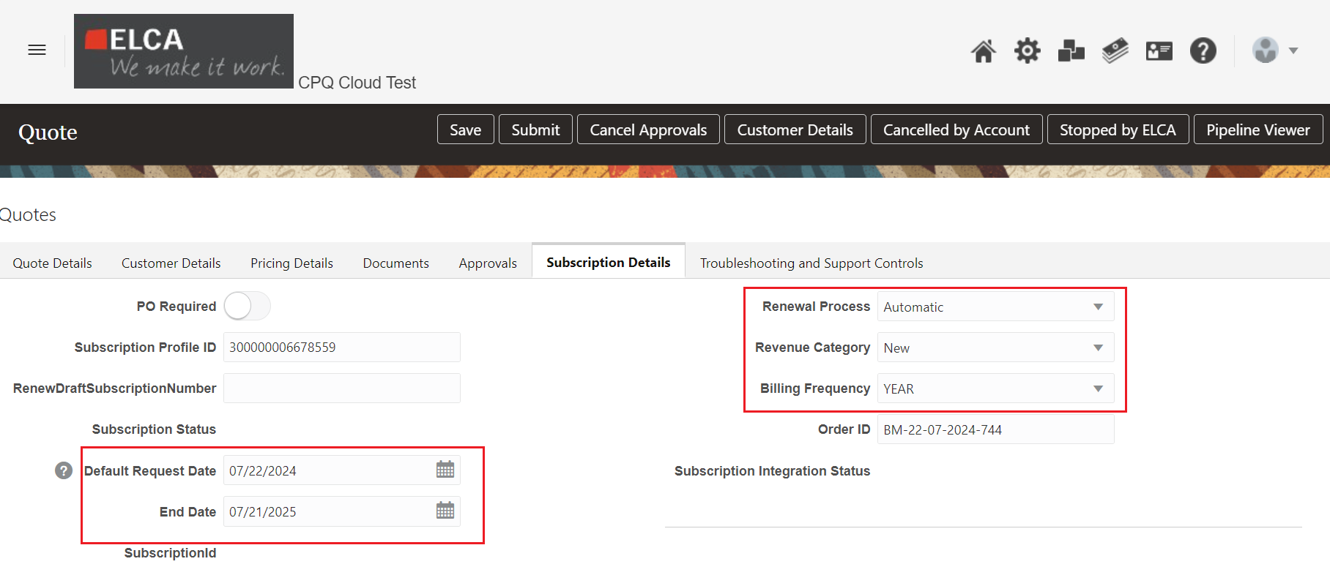

**Default Request Date** – Start date of entire subscription process.

**End Date** – End date of entire subscription process

**Renewal Process** – There are three renewal process which sales users can select while creating subscription for a customer.

* Automatic renewal – recurring payments process without customer intervention.
* Manual renewal – recurring payments require that the customer logs into the store and makes the payment for each payment interval.
* Do not Renew – For one time of subscription.

1. **Line Item Details:** Once Add the Part number to the Quote, it will show the below details in Transaction Line Details and Subscription Line Details.

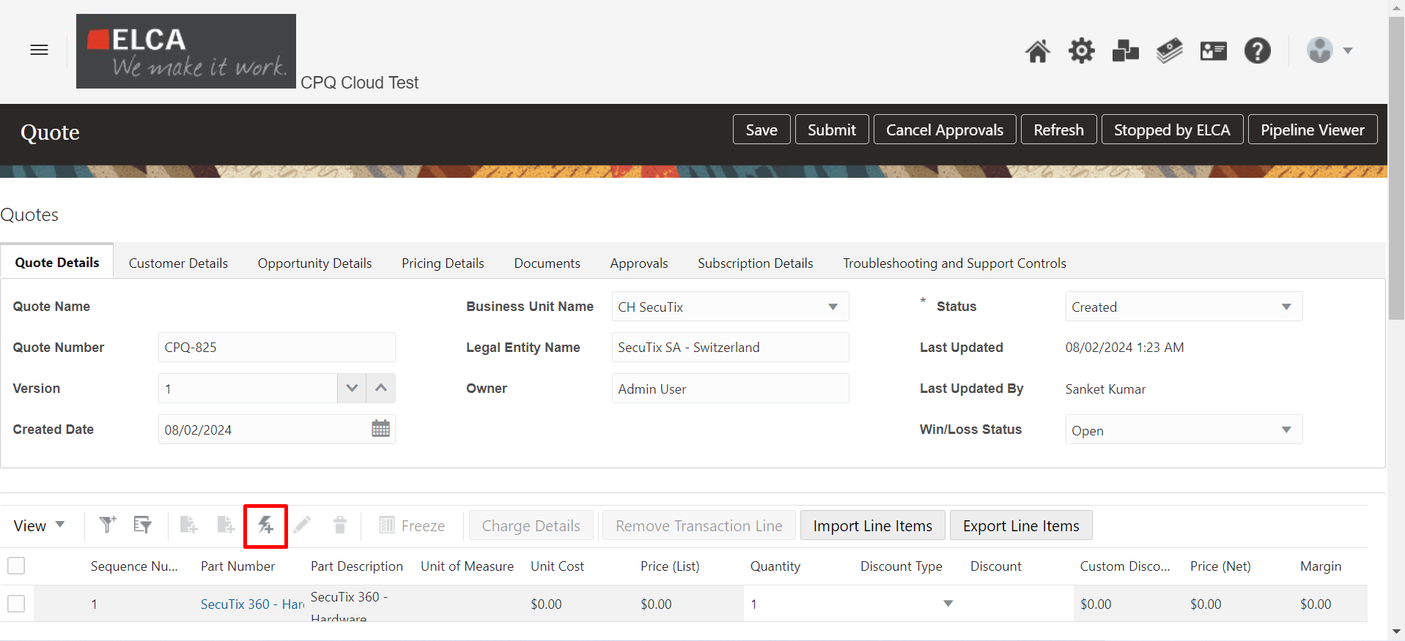

Items can also be imported in bulk by using “Import Line Items”. Clicking this, there will be an option to a CSV file where all the Transaction Lines with the necessary Pricing can be added.

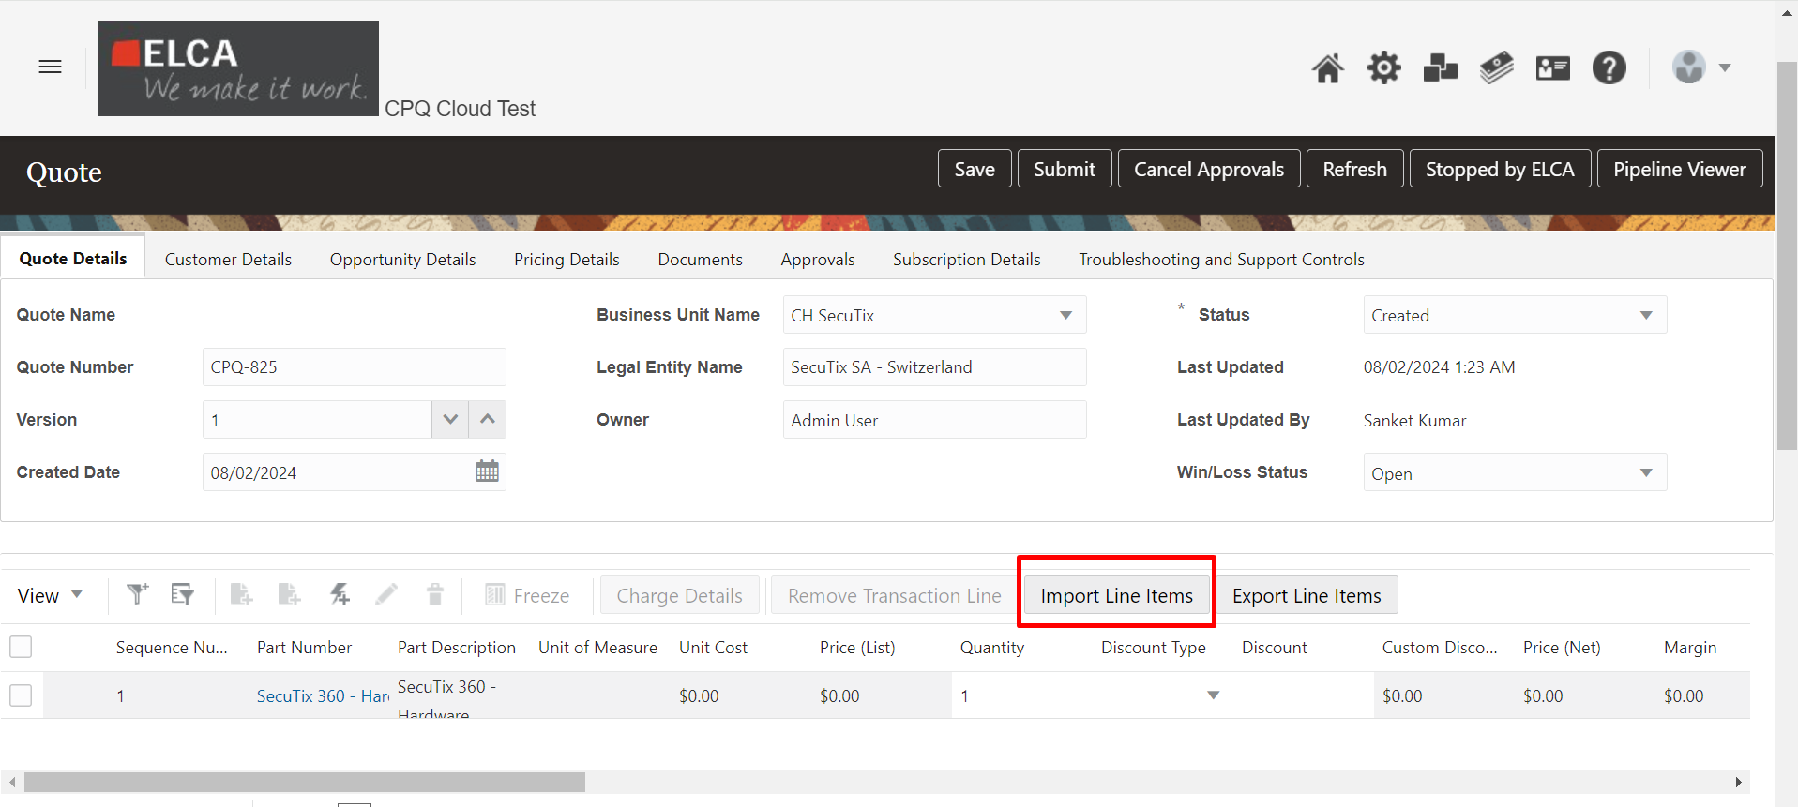

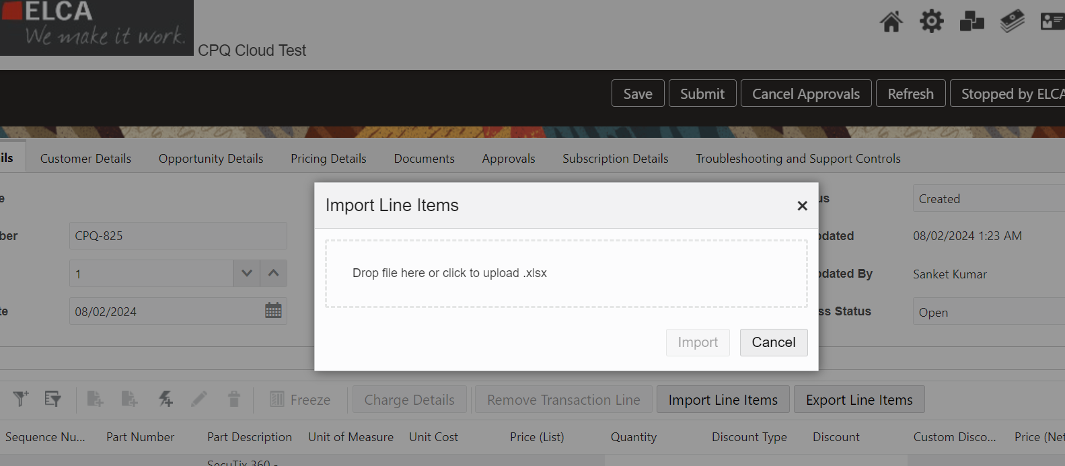

In order to manually update the line items, the below approach can be used:

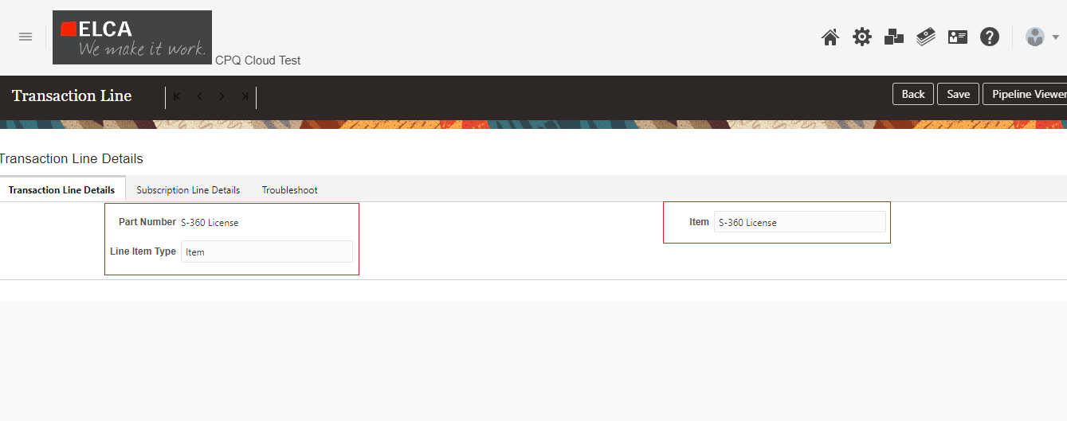

**Part Number**– Subscription Product

**Line Item Type** – Subscription Product Type

**Item** – Part Number

* Subscription Price has 3 types of Pricing Recurring, usage and one time and these Price Types will be populated automatically when user select the product.
* For period, user need to select Month or Year when pricing Type is Recurring and Usage.

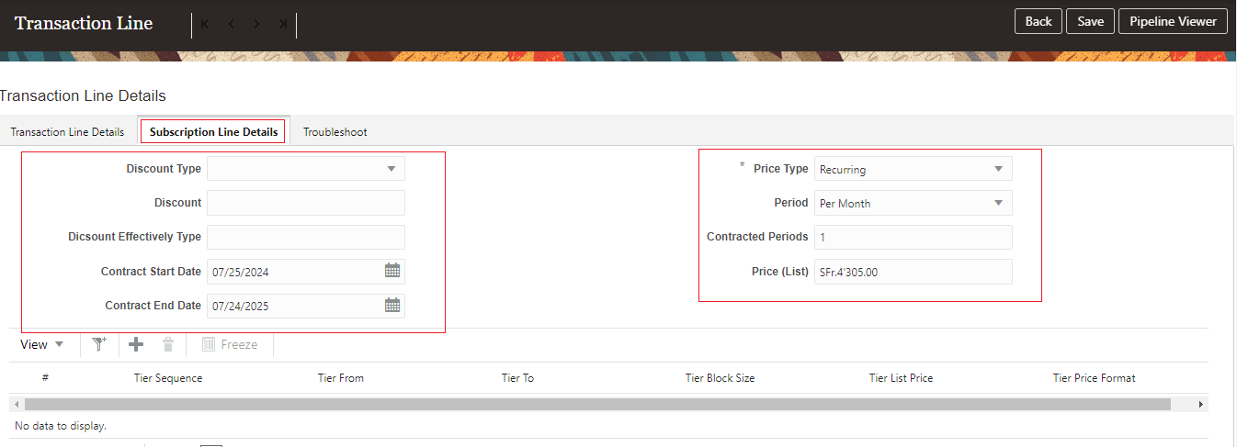

**Price Type** – will be populated automatically when user select the product.

**Period** – User can select based on Pricing Type

**Price (List)** –List price of Product

* Once the Subscription product added successfully, Click on **Create Subscription**

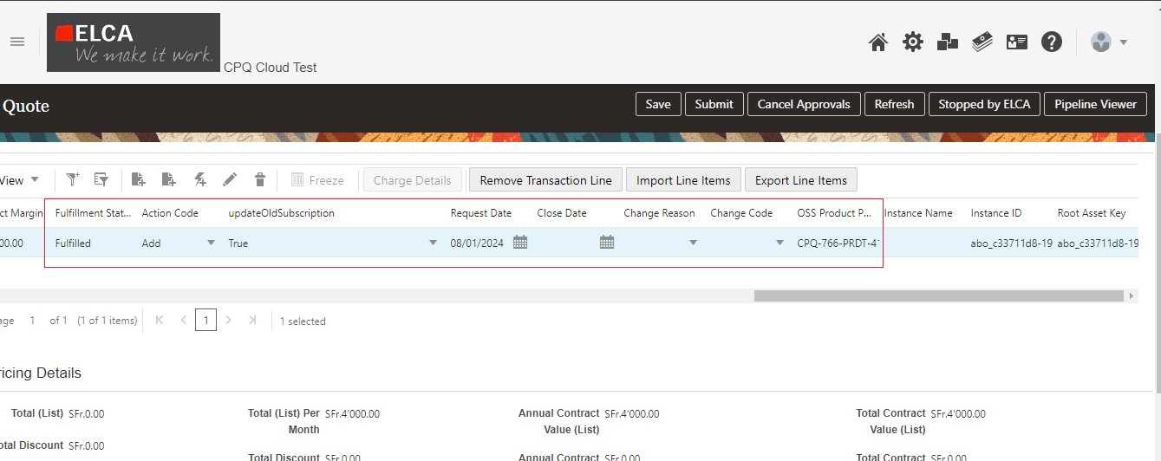

Upon successful subscription creation, below details will be updated in Subscription Line Item level.

**OSS Product PUID** – PUID will be generated automatically from OSS

**Fulfillment Status** – Fulfilled

**updateOldSubscription** – true

**Action Code** – Add

**5.6.2 Subscription Renewal:** The sales users can submit the quote for subscription Renewal in Subscription Management once the Subscription is created.

* In CPQ, user clicks on “Version Transaction” on the original quote. A new version of the quote is created and the user selects the following values:

**Change Reason (in Subscription Details tab):** “Subscription Renewal”

**Action code** (**in Transaction Line**): “Renew”

**UpdateOldSubscription (in Transaction Line)**: False

**1. Quote Details:** Update below necessary subscription details in Quote

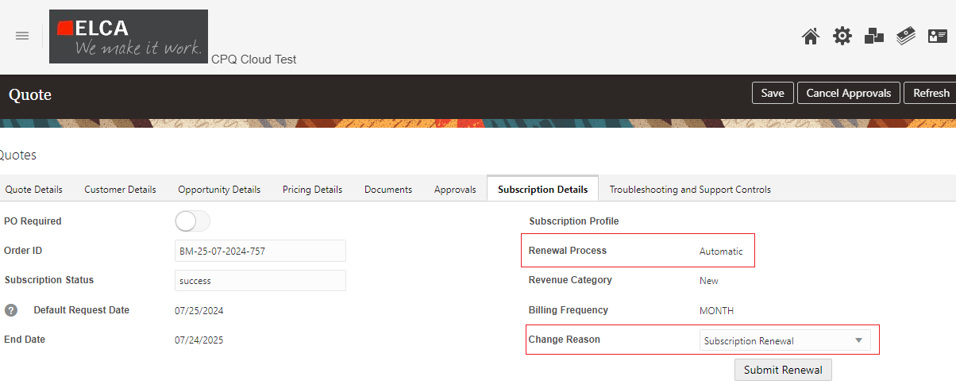

**Renewal Process** – user can select from **Automatic** / **Manual** / **Do not Renew**

**Change reason** –User select the **Subscription Renewal**

**Request Start Date** (in Quote header)

**Request End Date** (in Quote header)

**Contract Start Date** (in Transaction Line)

**Contract End Date** (in Transaction Line)

* After selecting the values, user clicks on **Submit Renewal** button.

**2.Line Item Details:** Once the Subscription Renewal is success, below Line Item fields are updated.

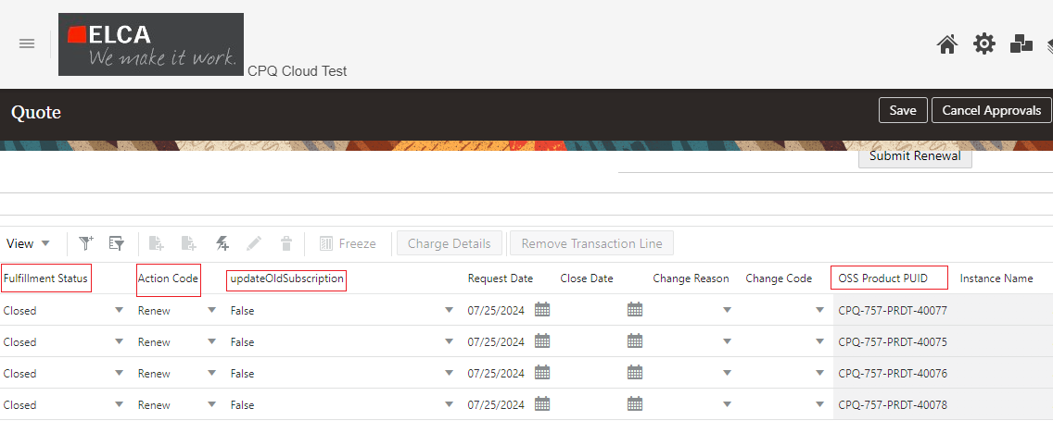

**OSS Product PUID** – PUID will be updated upon Subscription Renewal from OSS

**Fulfillment Status** – Fulfilled

**updateOldSubscription** – False

**Action Code** – Renew

**5.6.3 Subscription Amendment:** The sales users can submit the quote for subscription Amendment in Subscription Management once the Subscription is created.

* User clicks on “Version Transaction” on the original quote. A new version of the quote is created and the user selects the following values:

**Change Reason (in Subscription Details tab):** “Subscription Amendment”

**Action code** (**in Transaction Line**): “Add” or “Update” or “Terminate”

**UpdateOldSubscription (in Transaction Line)**: False

**1.Quote Details:** Update below necessary subscription details in Quote

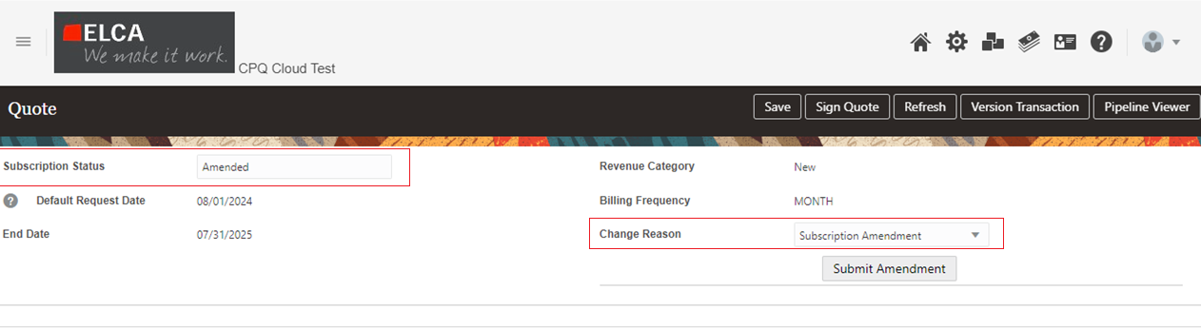

**Close Date -** Select today or future date to close/update subscription

**Change reason** –User select the **Subscription Amendment**

**2. Line Item Details:**

* Selects the **Action Code** at transaction line level as **Add** for Addition of new products
* Selects the **Action Code** at transaction line level as **Update** for updating the existing products
* Selects the **Action Code** at transaction line level as **Terminate** for Terminating the existing products
* Select Change Code at transaction line level to define the sales credit method while updating subscription
* For A**ction Code = Add or Update, Fullfillment Status**= **“FULFILLED”** and no need to update the Subscription PUID’s in CPQ

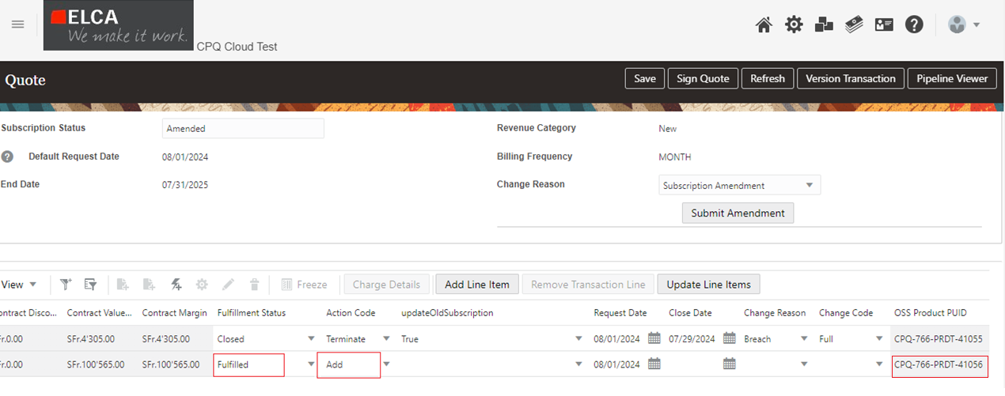

**OSS Product PUID** – PUID will be updated upon Subscription Amendment from OSS

**Fulfillment Status** – Fulfilled

**Action Code** – Add /Update/Terminate

**5.6.4 Subscription Termination:** The sales users can submit the quote for subscription Termination in Subscription Management once the Subscription is created.

* In CPQ, user clicks on “Version Transaction” on the original quote. A new version of the quote is created and the user selects the following values:

**Change Reason (in Subscription Details tab):** “Subscription Termination”

**Action code** (**in Transaction Line**): “Terminate”

**UpdateOldSubscription (in Transaction Line)**: False

**1.Quote Details:** Update below necessary subscription details in Quote.

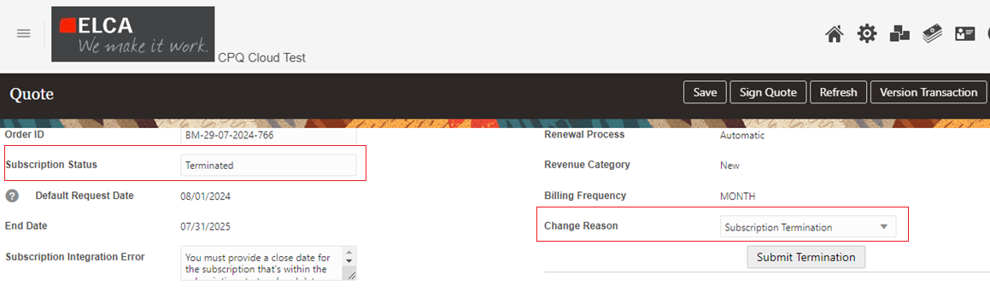

**Change reason** –User select the **Subscription Termination**

**2.Line Item Details:** Once the Subscription is Terminated, below Line Item fields are updated

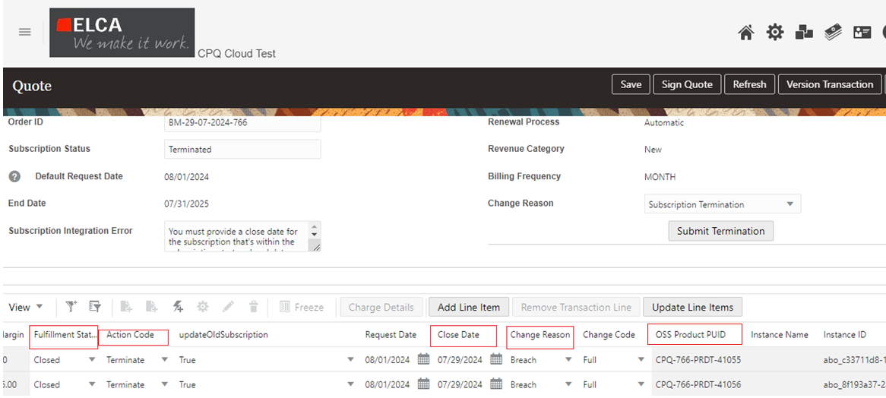

**Action Code** – User can select Terminate

**Close Date** - Select today or future date to close the subscription line

**Change Reason** – Select a reason for closure/termination of the line

**Change Code** - To define the sales credit method while updating subscription

* After selecting the values, user clicks on **Submit Termination** button.

# 6. Manage Subscriptions (Oracle Subscription Management)

## 6.1 Creating Item/Product for Subscription and CPQ

New items are created in Product Information Management (PIM) in Oracle Fusion, and thus can be readily utilized within Subscription Management. These items are then automatically synchronized to Oracle CPQ for use within Quotes as well.

### 6.1.1 Steps to create an Item

1) Open Oracle Fusion

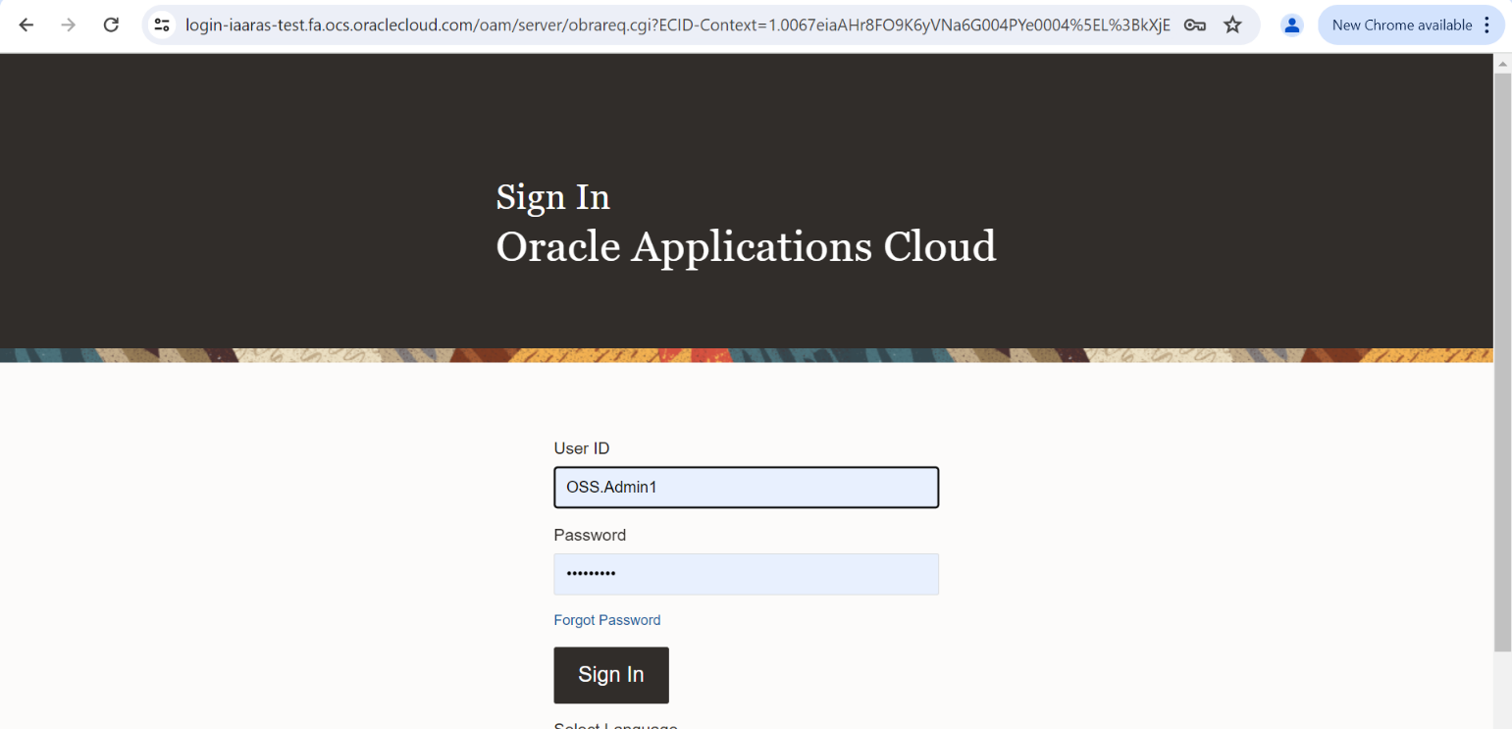

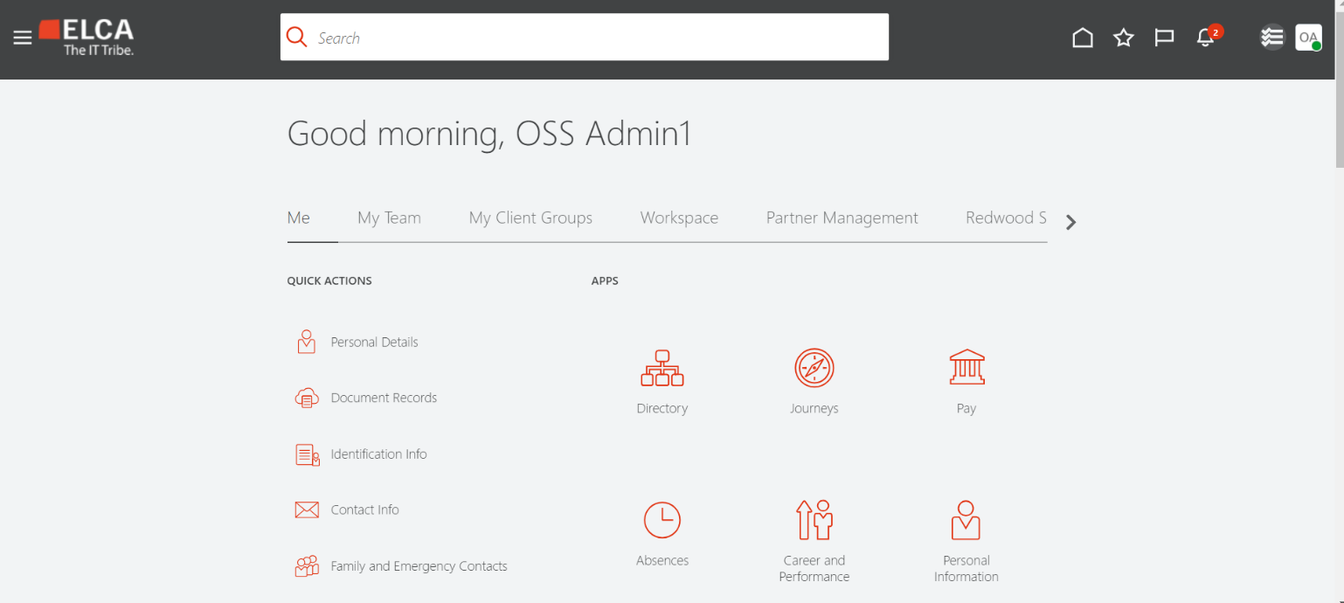

2) Open Product Information Management

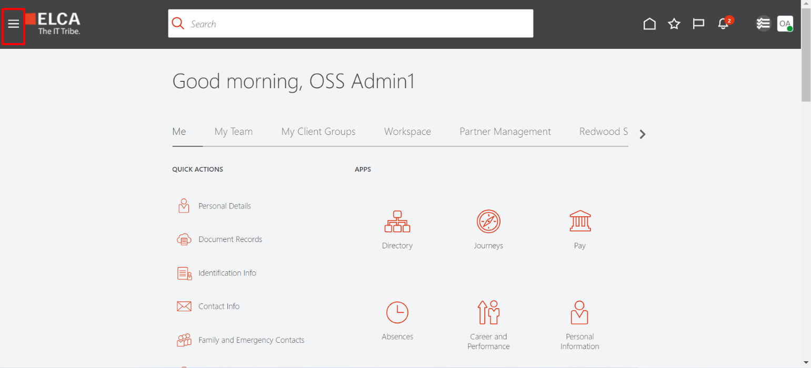

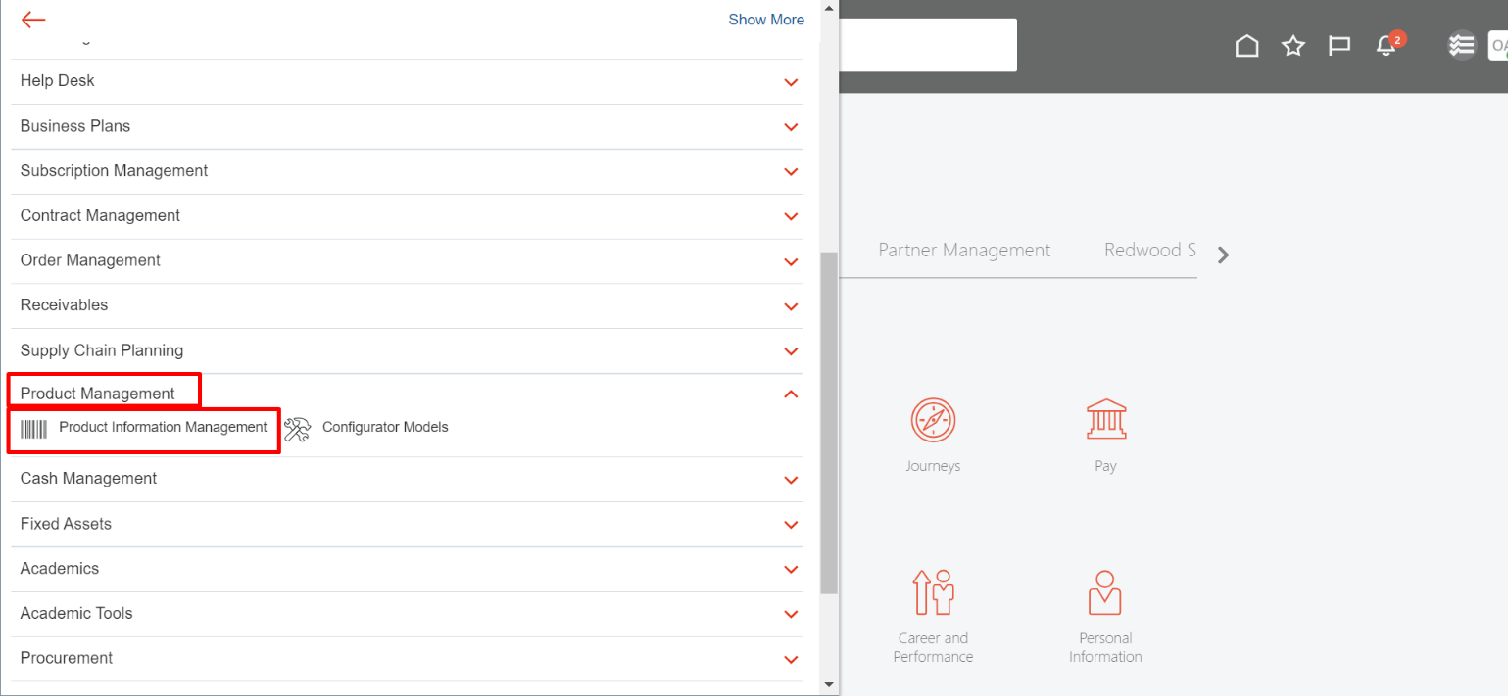

3) Click on “Create Item”

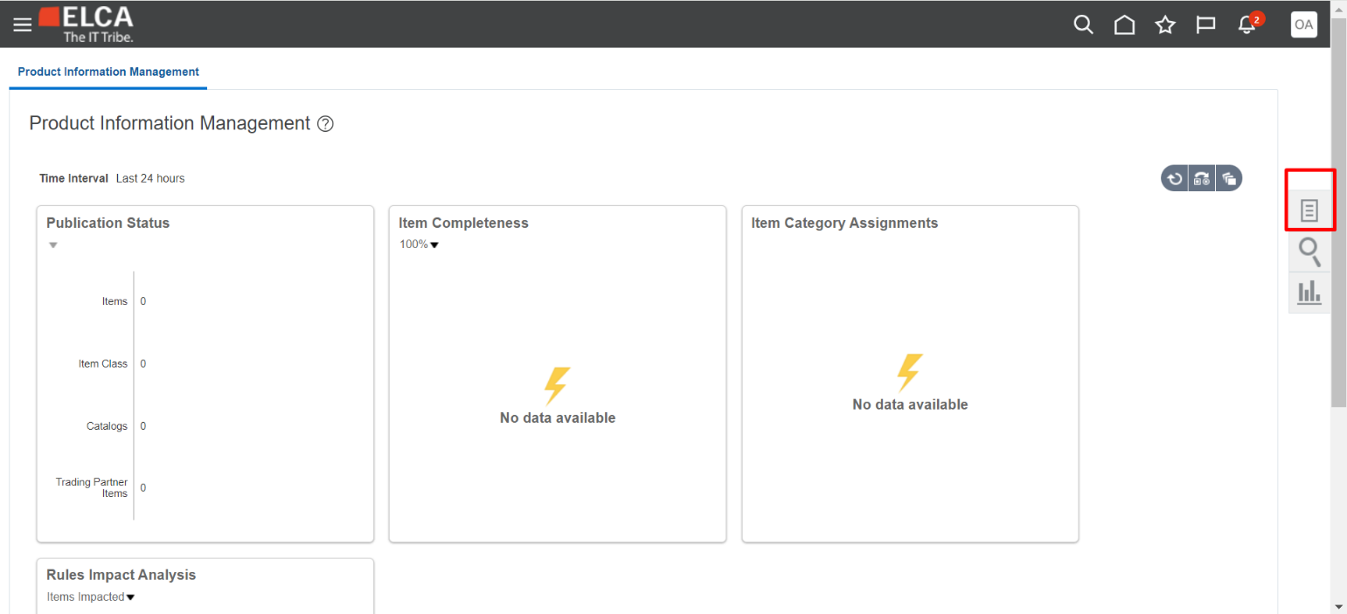

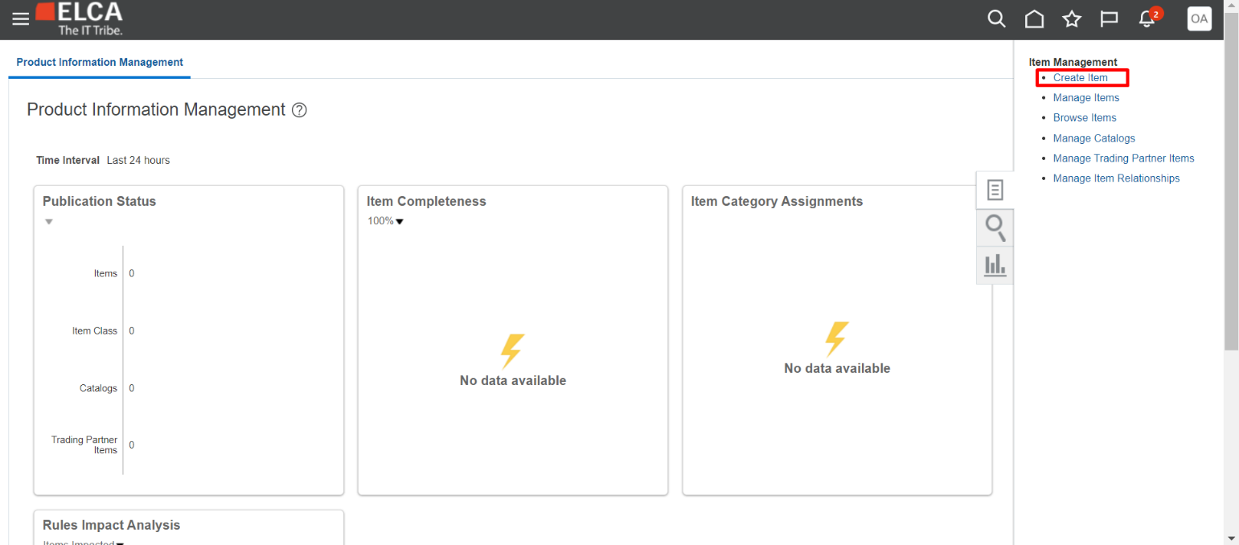

4) Click on “OK”

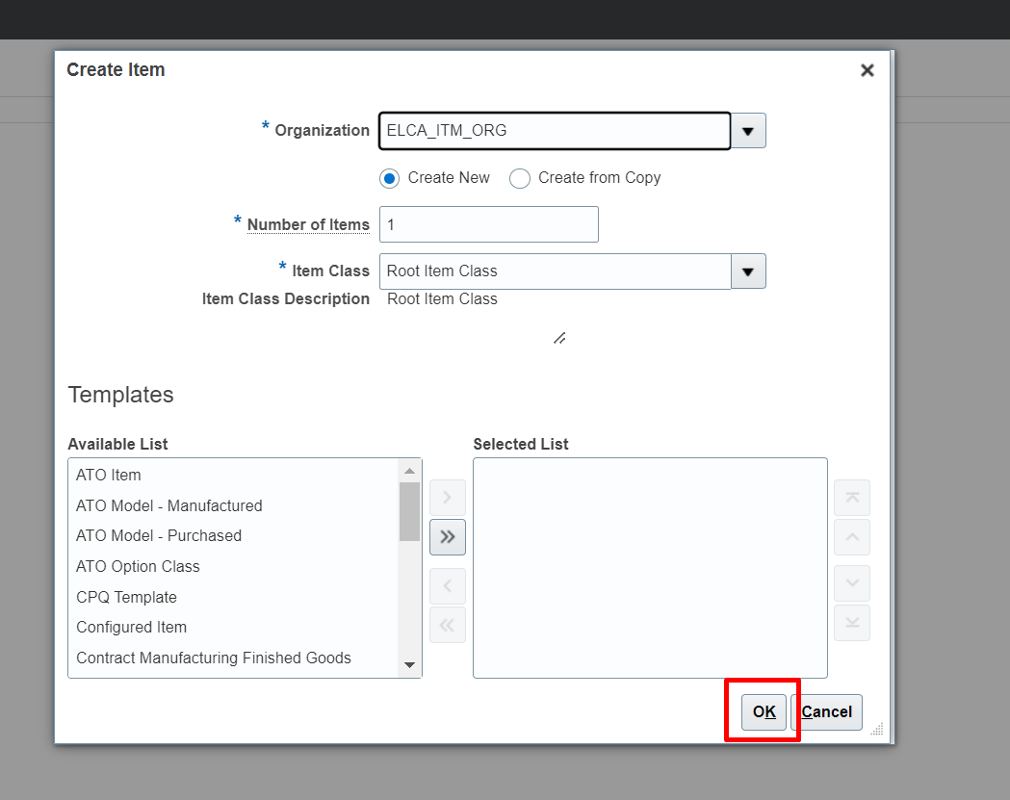

5) Select “Item Name”, “Description” and “Primary Unit of Measure”. Note that Item Name will also serve as the Item Code and will not be editable after the item is Active.

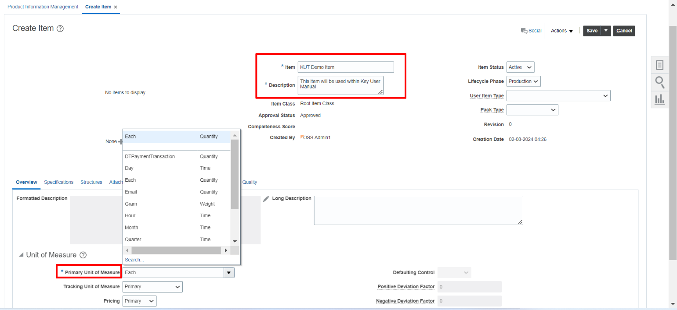

6) Once done, click on “Specifications” and select “Sales and Order Management”

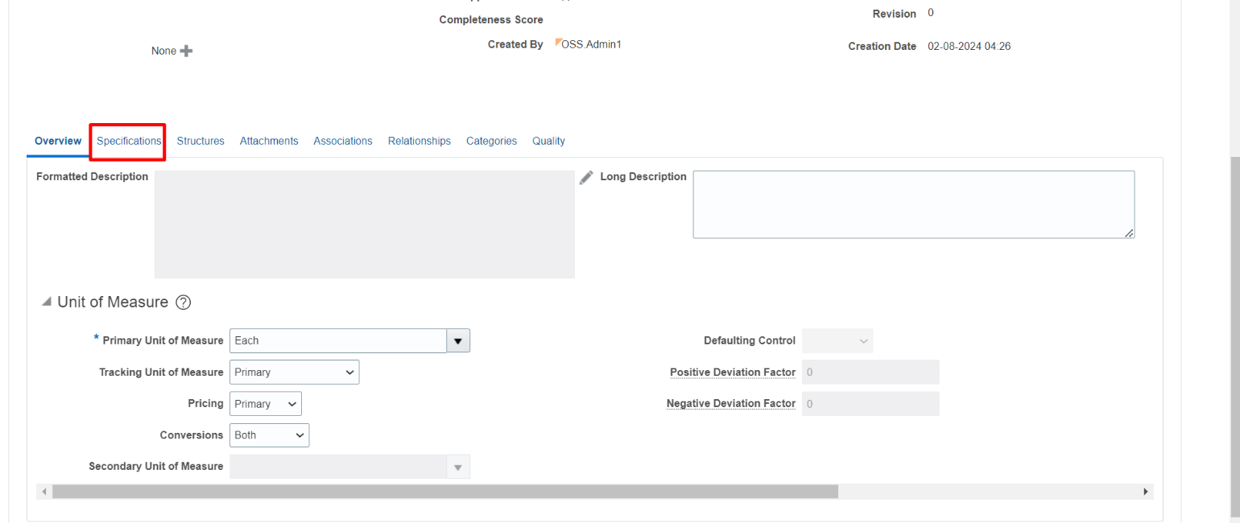

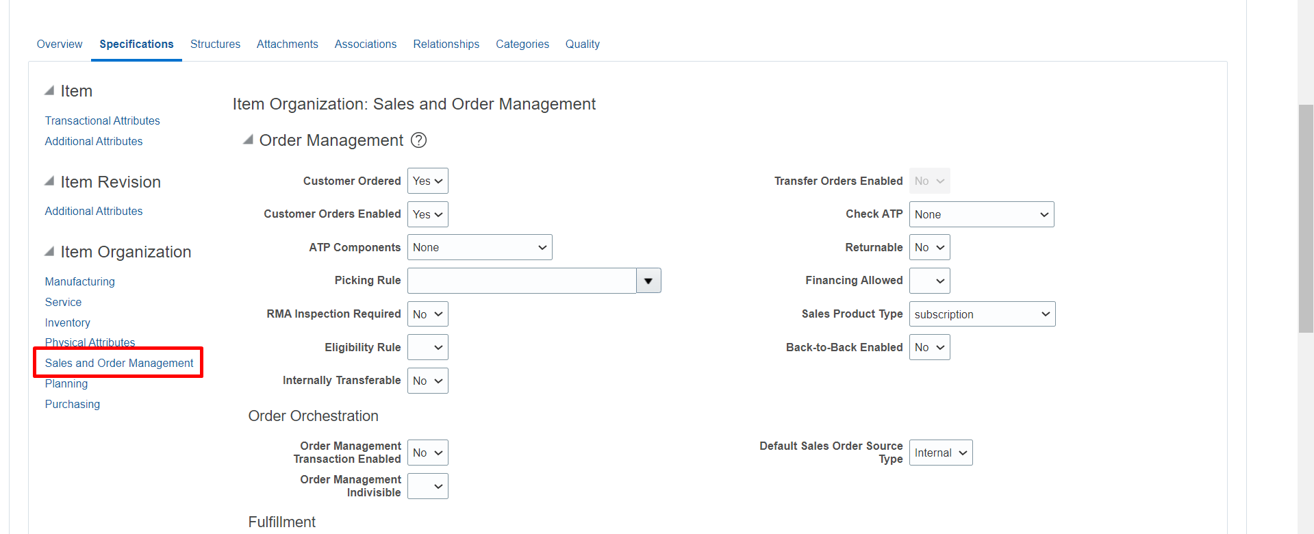

7) User needs to select the following parameters with the following values:

- Customer Ordered: Yes

- Customer Orders Enabled: Yes

- Sales Product Type: Subscription

- Invoiced: Yes

- Invoice Enabled: Yes

8) Click “Save” and then “Save and Close”

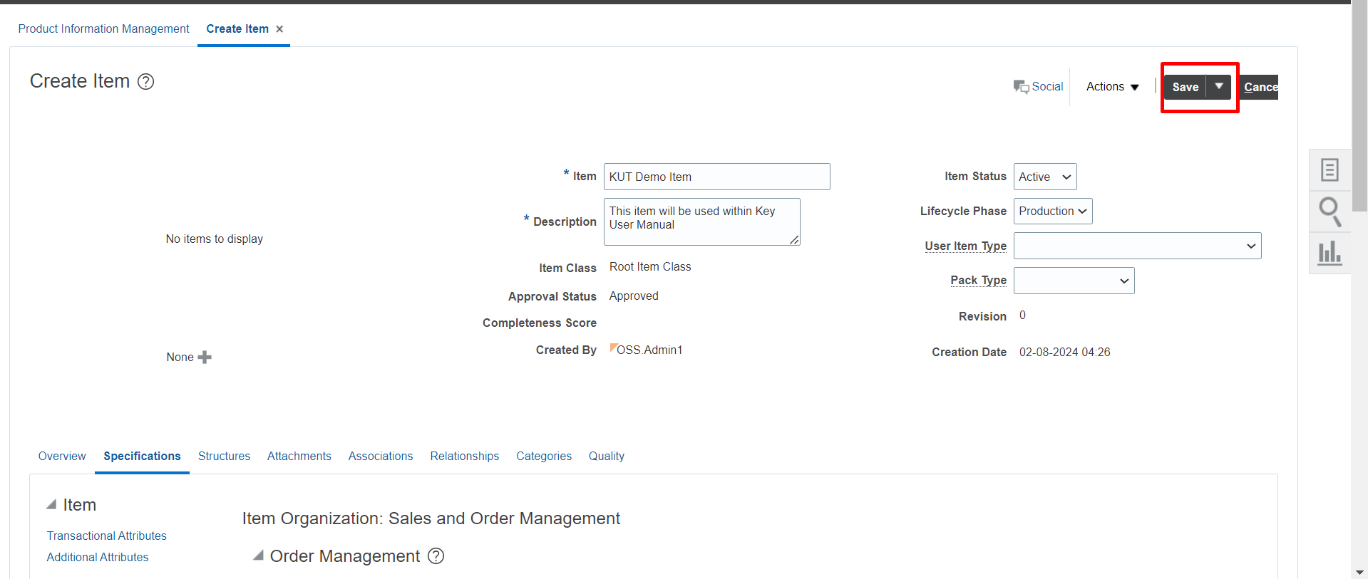

Once this is done, a periodic sync set up in Oracle CPQ will pull this product on the basis of “Sales Product Type” = Subscription, into CPQ Parts Table. This item/part will then need to be added within the Pricing/Charge Table of CPQ manually.

### 6.1.2 Adding the item/part in CPQ Pricing Database Table

1) Login to CPQ

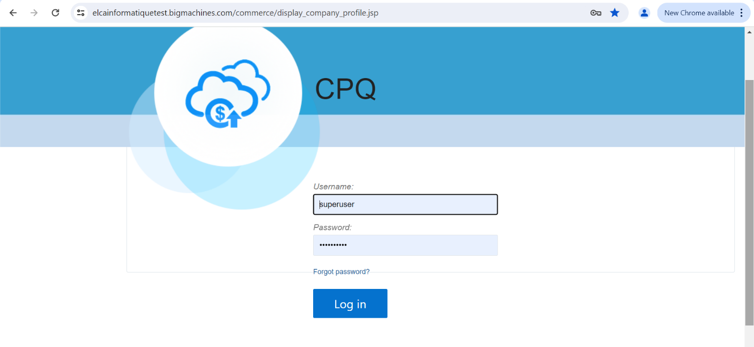

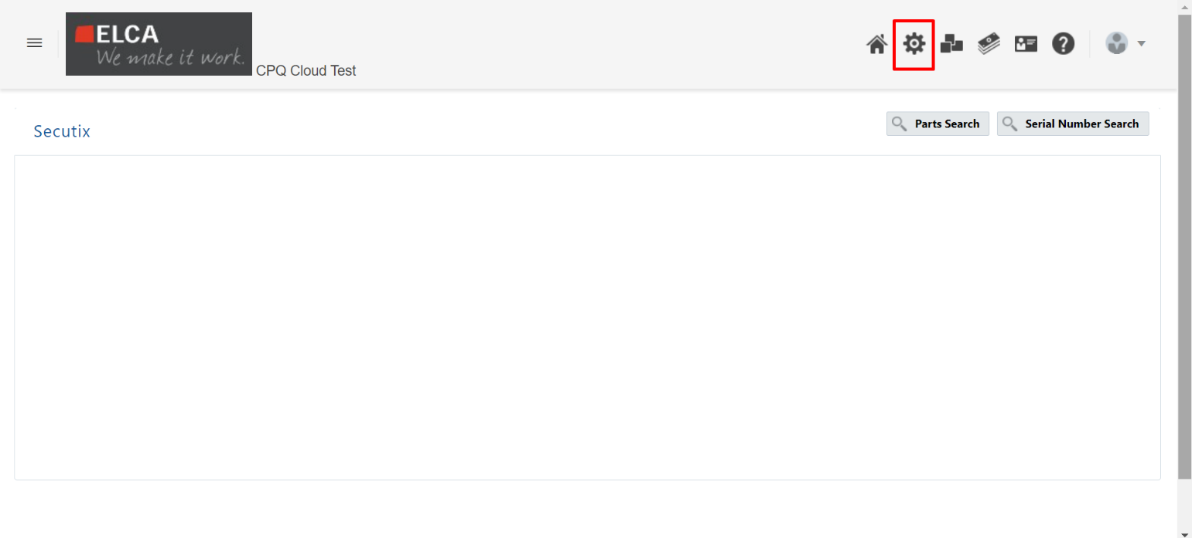

2) Open Database Tables

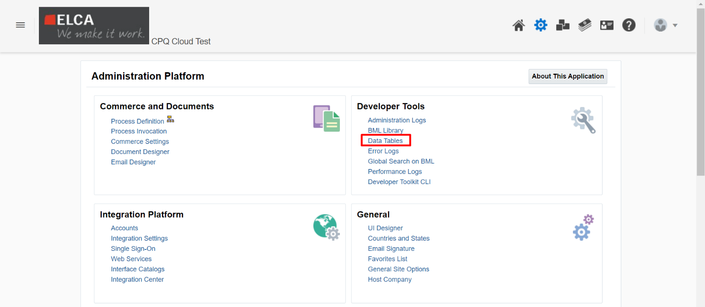

3) Open Pricing Tables (click on the arrow)

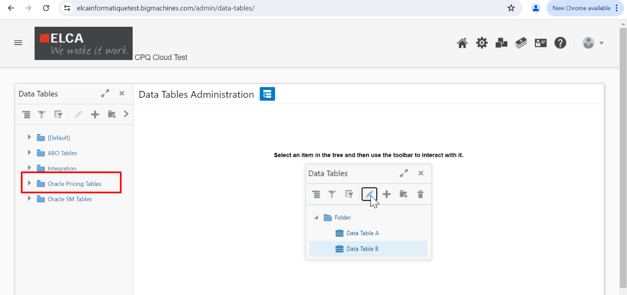

4) Open the ORCL_PRC_BASE_CH and click on “+”

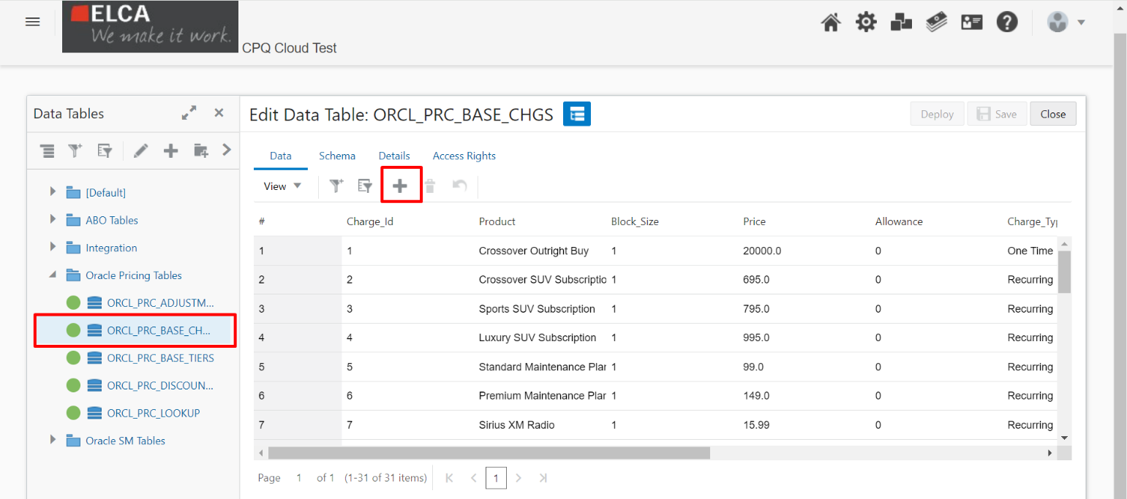

5) A new charge line opens

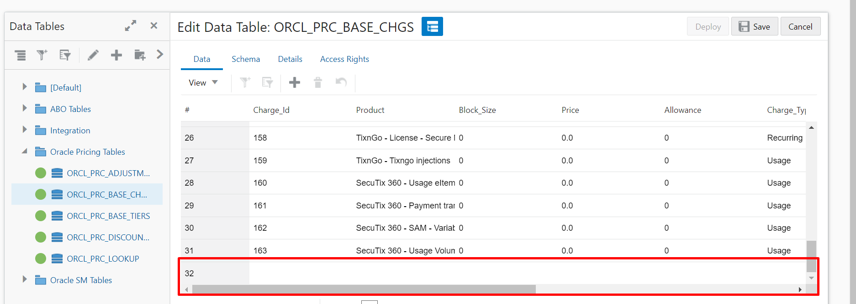

6) User can add the charge number in sequence, and then add the synced part. Post that, charge type and pricing can be updated

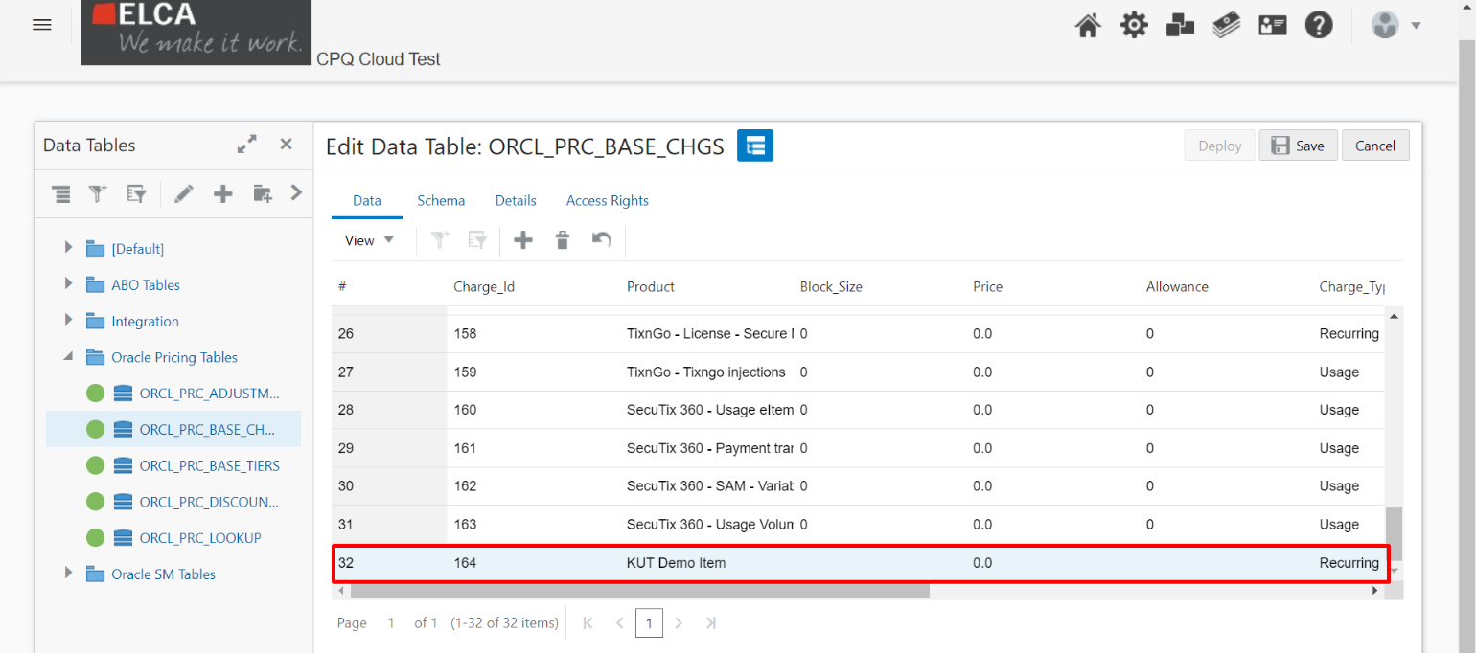

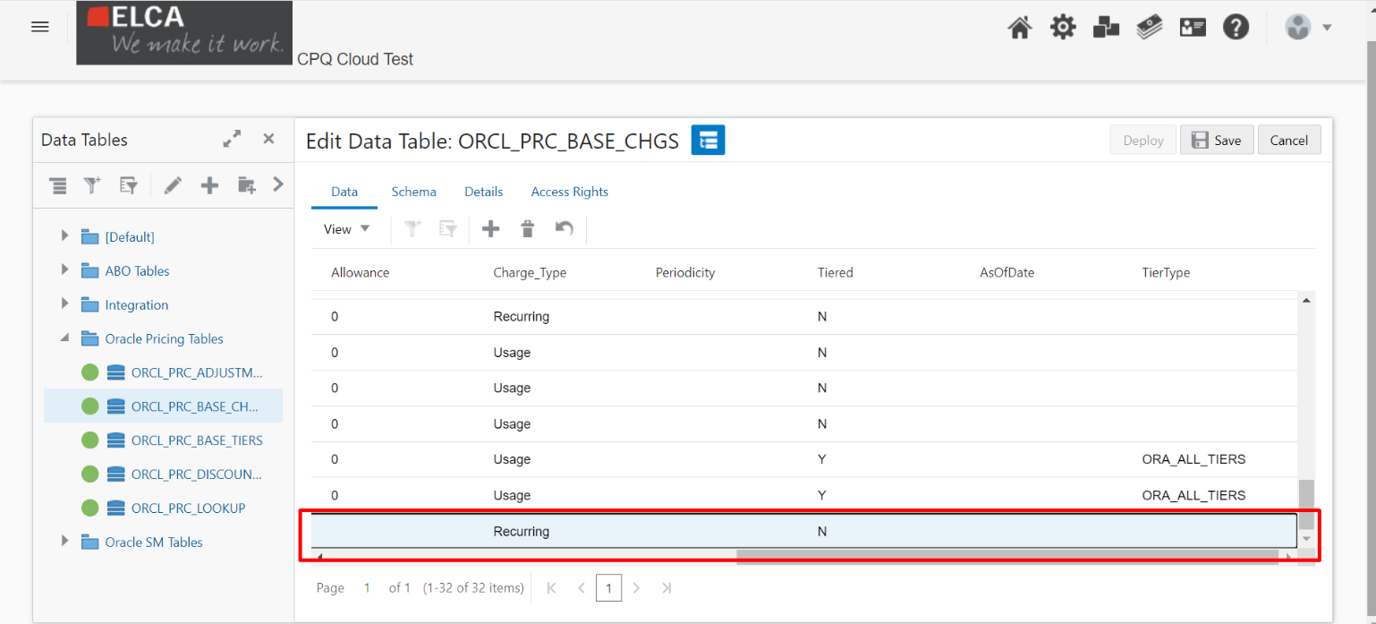

The item/part is now ready to be used in CPQ & Subscription.

## 6.2 Subscription Structure

Subscriptions are automatically created in Subscription Management after the CSM/Sales Reps/Offer Specialists click “Create Subscription” in CPQ. Most of the attributes within Subscription Management will be read-only, as modifications will need to be triggered from Oracle CPQ.

The Subscriptions are divided into multiple levels:

### 6.2.1 Subscription Header

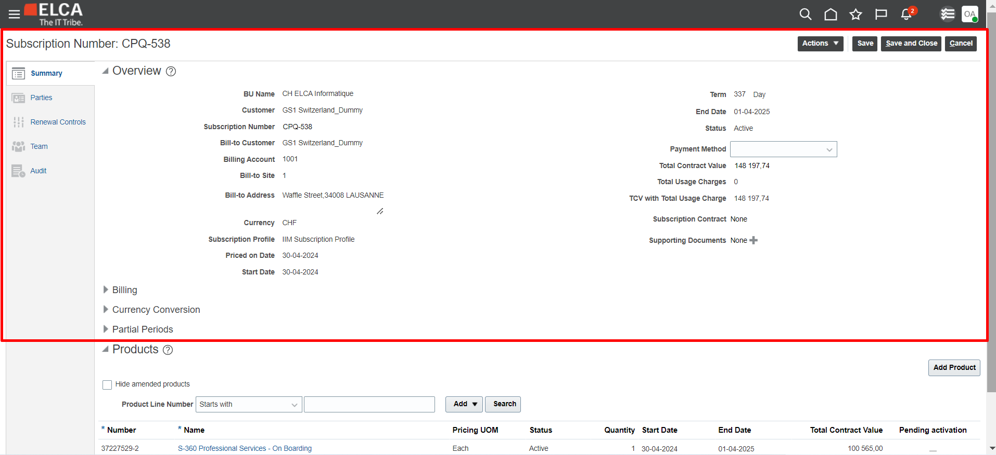

### 6.2.2 Subscription Products

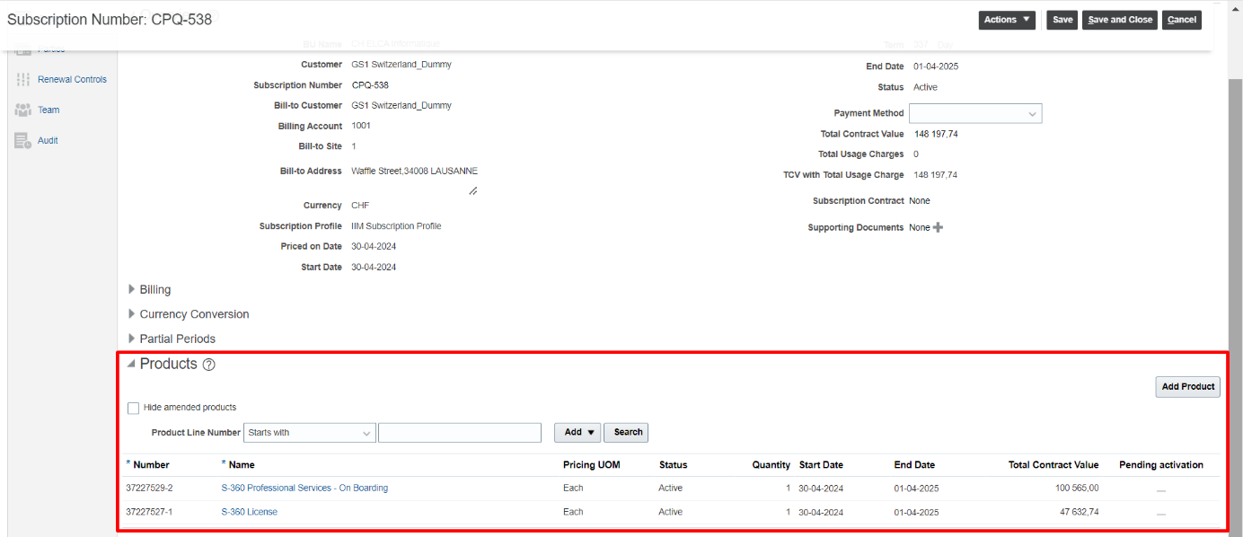

### 6.2.3 Subscription Product Pricing

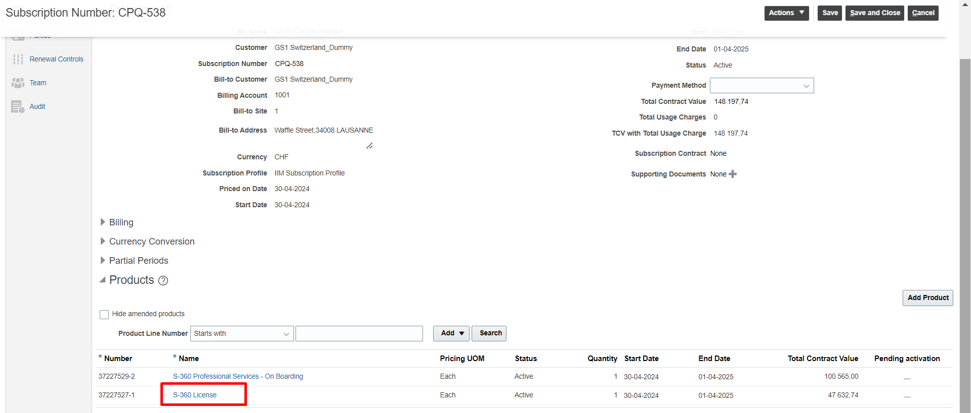

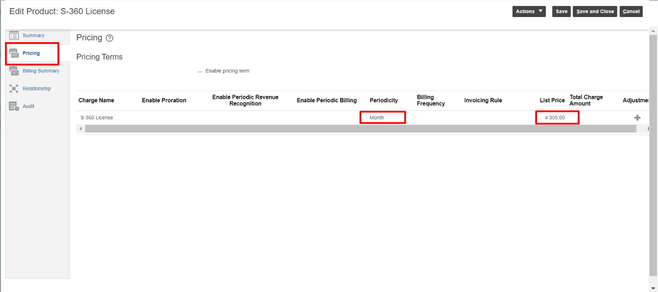

### 6.2.4 Subscription Product Billing Summary

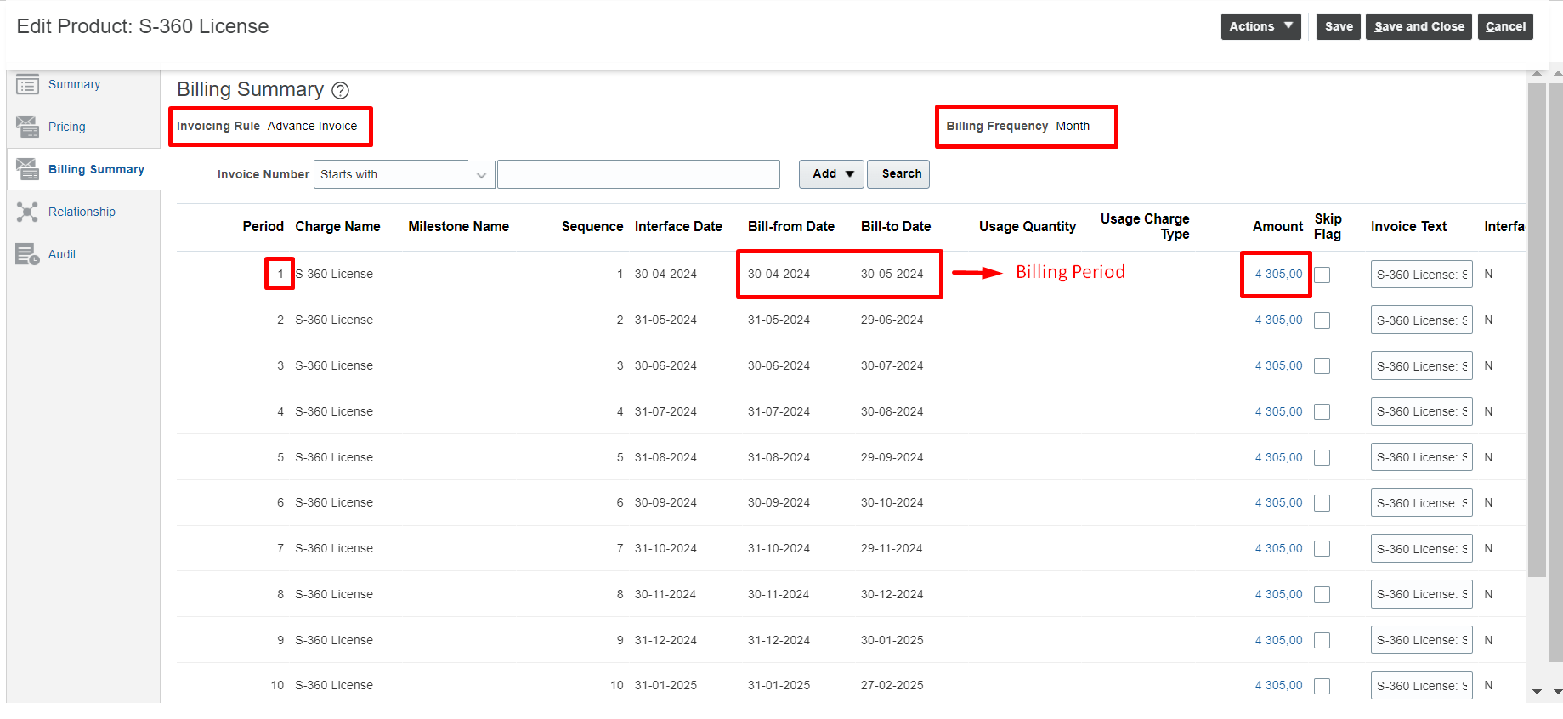

This Billing Summary tab also consists of important tabs like “Usage Quantity”, “Skip Flag”, “Interfaced?”, “Invoice Number”, “Invoice Date”, and “Invoice Amount”. Below is the relevance of each of these attributes:

**1) Usage Quantity:** Only relevant to Usage/Consumption based Subscription Products. **The value in this field will be populated daily from S-360 Platform.** Once the usage quantity is populated, Subscription Management is going to auto-calculate the applicable amount by multiplying the unit price as applicable in the “Pricing” tab.

**2) Skip Flag:** This field is useful to check the lines which do not require to be interfaced to Accounts Receivables. A very important use-case for this flag/checkbox will be during data migration, where every past billing line which has already been invoiced needs to be checked.

**3) Interfaced:** This field shows whether the Bill Line has been interfaced to Accounts Receivable or not. This value cannot be controlled manually or using any API. It only gets set based on the success of the Scheduled Processes.

**4) Invoice Number:** This field shows the value of the Invoice Number that was generated in Accounts Receivables.

**5) Invoice Date:** This field shows the date on which the Invoice was created. Unless there is an Offset that is applied, Invoice Date will be the same as the Interface Date on the Bill Line

**6) Invoice Amount:** This will be the actual amount that will be passed in the Invoice including Tax

## 6.3 Manage Subscription Actions

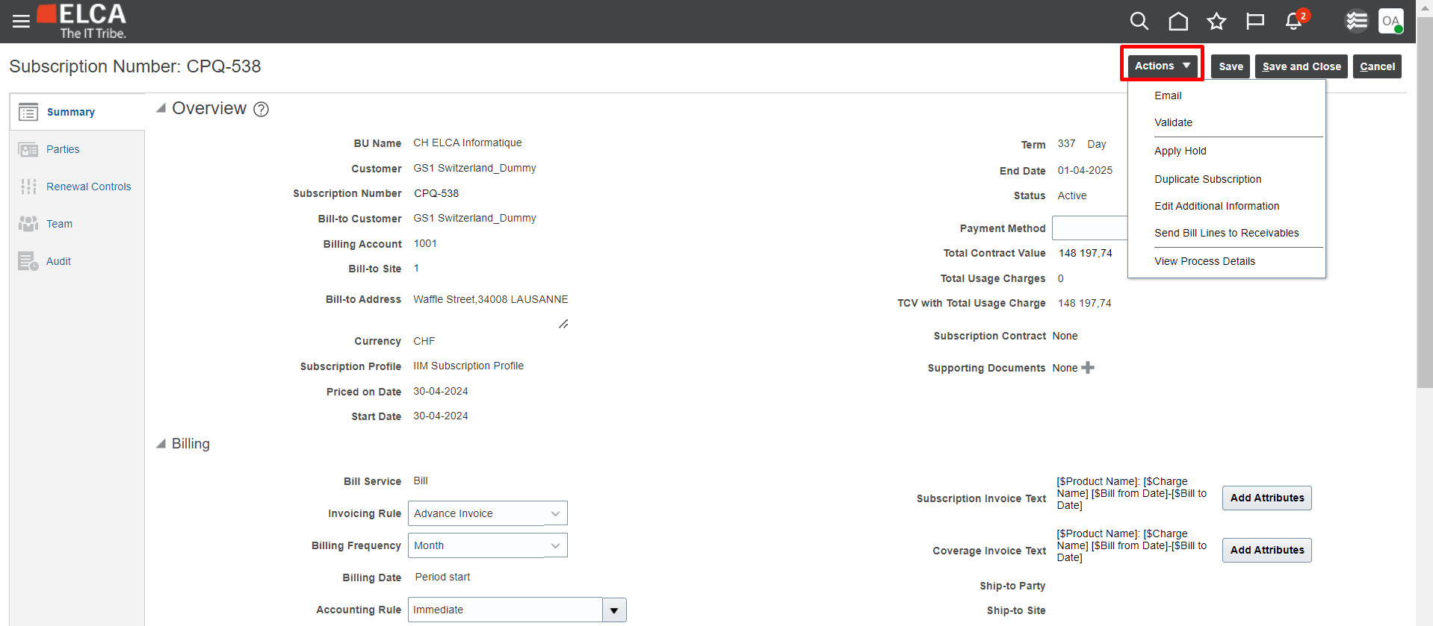

Subscription Actions are an integral part of Subscription Management. Here’s the breakdown of what each of the actions are capable of doing:

### 6.3.1 Email

Email helps a user to send the Subscription to any email addresses

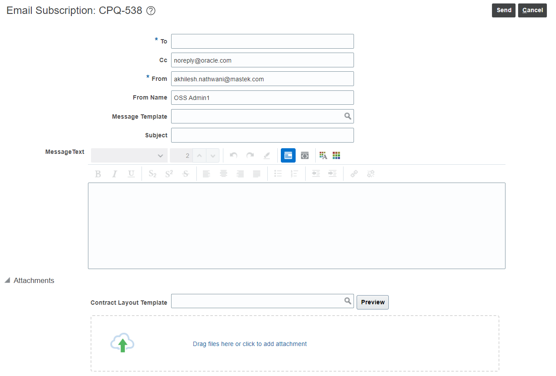

### 6.3.2 Validate

This action allows the user to validate the Subscription in case there are any manual changes made on the Subscription. This action runs automatically before Subscription activation, so unless something has been changed on the Subscription, this action is not required.

### 6.3.3 Apply Hold

This action is a critical action that can allow the user to put the Subscription on-hold for a temporary period of time. This will avoid any billing for the period in which the Subscription is on-hold.

### 6.3.4 Duplicate Subscription

This action helps to duplicate a Subscription for any manual activity that needs to be done on Subscription Management, and requires the same Subscription details to be in place.

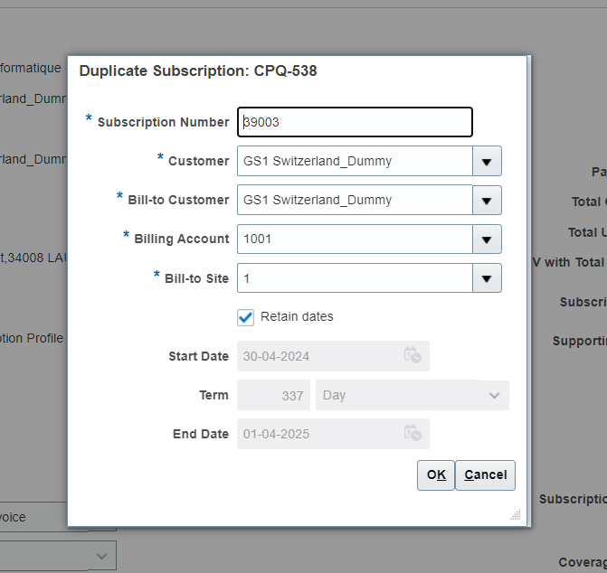

If the user wants to use a different set of dates, or period, they can uncheck “Retain Dates” to make Start Date, Term and End Date to be editable.

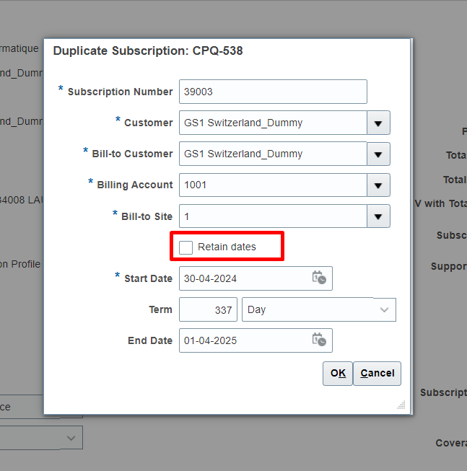

### 6.3.5 Send Bill Lines to Receivables

This action allows the user to manually trigger the due Bill Lines to Oracle Accounts Receivables. This process of Billing Lines interface from Subscription Management to Accounts Receivables works in a sequence of 3 Scheduled Processes (ESS Jobs):

1. **Send Bill Lines to Receivables:** Sends all the due Bill Lines from Oracle Subscription Management database table to an interface table
2. **Import AutoInvoice:** Sends all the bill lines from the interface database table to Accounts Receivables database table
3. **Fetch Subscription Invoice Information from Receivables:** Sends invoice information back to Subscription Management on the specific bill line and marks “Interfaced” as Y.

**Subscription users need not trigger “Send Bill Lines to Receivables” manually, as all the 3 Scheduled Processes above will be running automatically at a defined frequency. Changing this frequency will require an Administrator role.**

## 6.4 Understanding Subscription Profiles

Subscription Profiles are the heart of Subscription Management. They ensure to set the right Billing Parameters in Subscription Management. A subscription profile is in some ways, a pre-defined billing template which auto-sets the required parameters, but also gives a flexibility to be overridden from CPQ at the time of processing the quote.

The below steps can be followed to access Subscription Profiles area:

1. Open the “Subscription Configuration” area. This is where most of the subscription configurations are available.

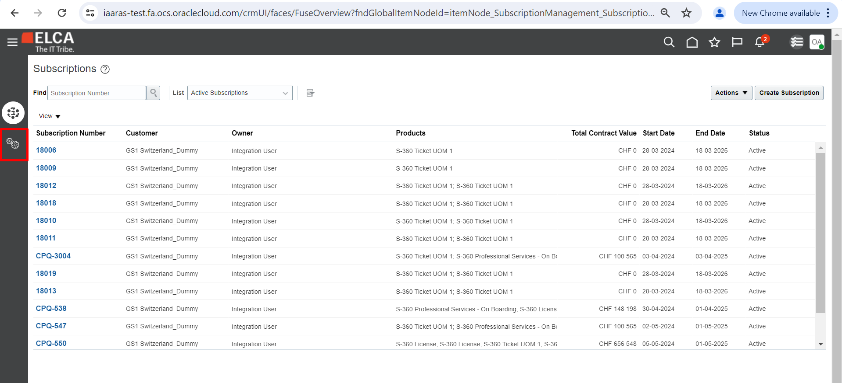

1. Click on “Manage Subscription Rules”

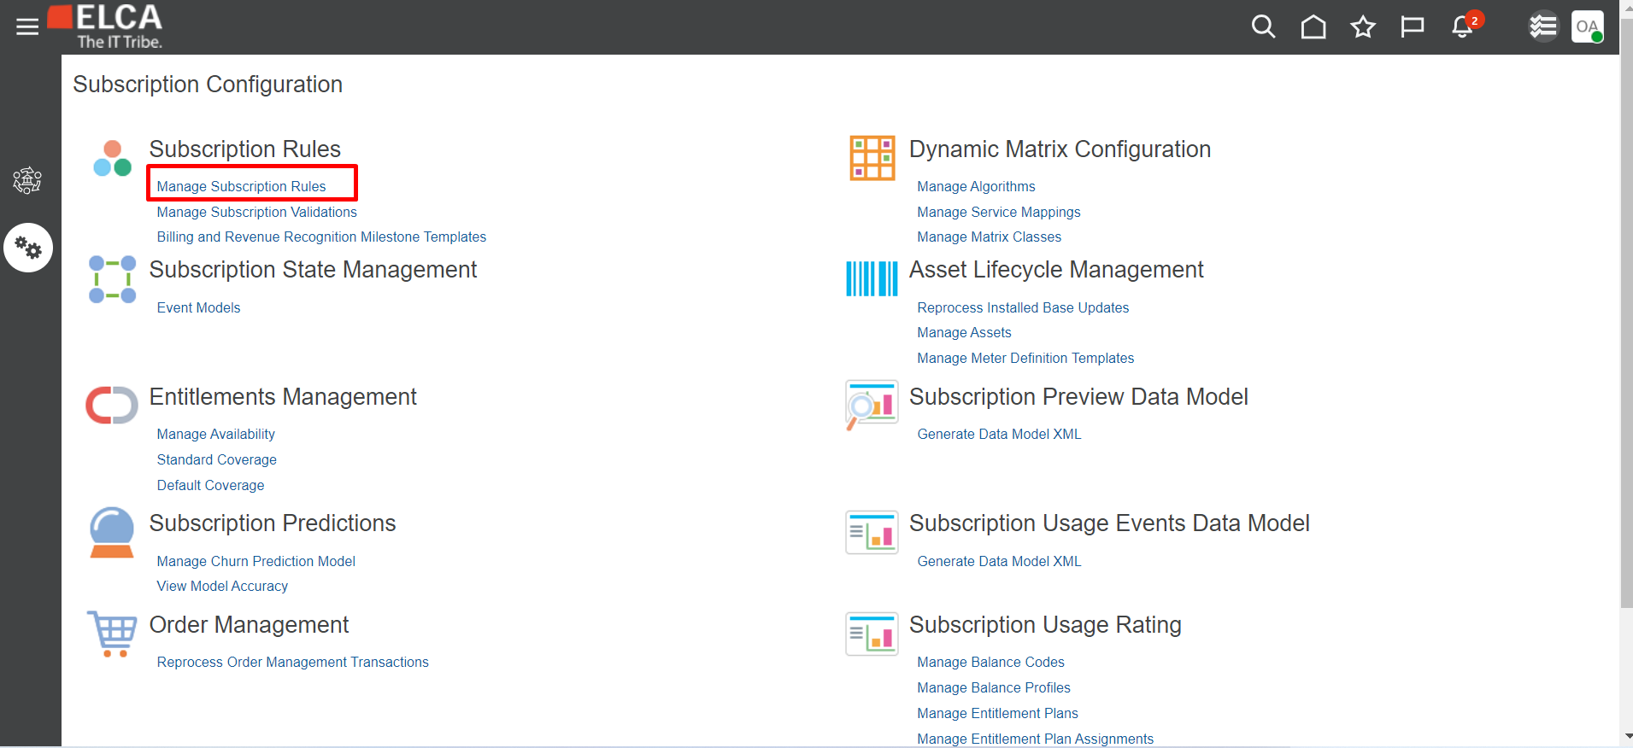

1. Click on Subscription Profiles tab

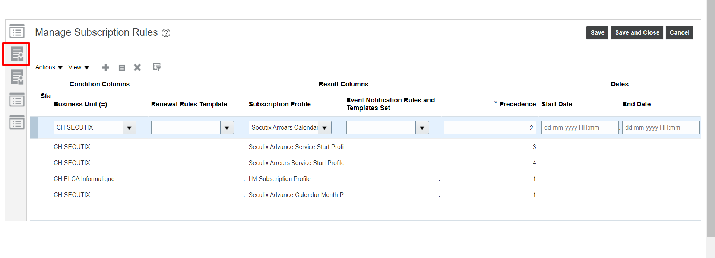

1. Click on any Subscription Profile which you want to review

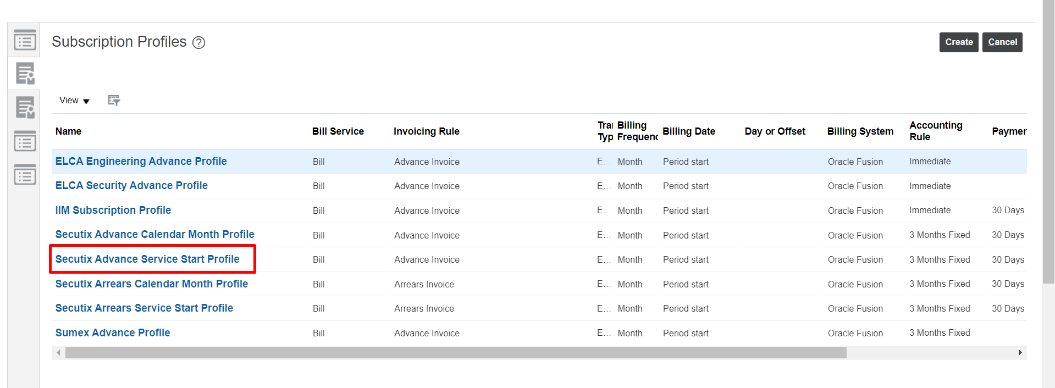

1. Review the details within the Subscription Profile

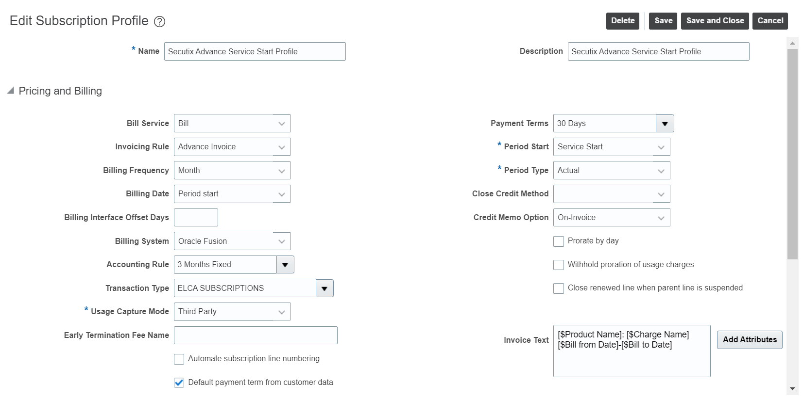

The important attributes within Subscription Profiles are as follows:

1. **Bill Service:** The options are Bill, Don't bill, and Bill on renewal. This option is only possible to be set on a Subscription Header level, and not on Subscription Product level.
2. **Invoicing Rule:** You can select between bill payments in the form of Advance Invoice and Arrears Invoice.
3. **Billing Frequency:** You can select the following billing periods: Month, Year, Quarter, and Year
4. **Billing Date:** You can select from Period Start, Period End, Day, and Offset. For example, if you select Period Start, the billing happens at the start of the defined period. If you select Offset, then the billing starts after the number of days defined in offset. The invoice date is controlled by the Billing Date. For example, you can set Billing Date as Period Start so that the invoice date is always at the beginning of the billing period. In some situations, you may want to send invoices to Account Receivables 3 days prior so that invoices can be prepared and sent out to customers on or before the invoice date.
5. **Accounting Rule:** You can select this to determine the rule for revenue recognition. For Secutix, this rule will be “Immediate” as we want to drive Revenue Recognition on the basis of Accounting Calendar setup to recognize revenue on a “Monthly” basis
6. **Transaction Type:** You can select this to determine if the billing is going to be an Invoice or a Credit Memo.
7. **Payment Terms:** You can select to have various types of payment methods, such as Immediate, Last Day Month, Due 10th, and so on. This indicates the period within which the customer must pay.
8. **Billing System:** The billing system can have a valuer of either Oracle Fusion or Third Party. Since billing & invoicing for Secutix will be done via Oracle Fusion, this value will ALWAYS remain Oracle Fusion.
9. **Period Start:** You can select your billing period to begin either on the date on which the service began: Service Start, or Calendar month. E.g. if the Subscription is active from 4th August 2024 to 3rd July 2025, where Billing Frequency will be “Month”, then the periods generated if Service Start is selected will be:

Period 1: 4th August 2024 – 3rd September 2024

Period 2: 4th September 2024-3rd October 2024

Etc.

However, if the Subscription is active from 4th August 2024 to 3rd July 2025, where Billing Frequency will be “Month”, then the periods generated if Calendar Month is selected will be:

Period 1: 4th August 2024 – 31st August 2024

Period 2: 1st September 2024-30th September 2024

Period 3: 1st October 2024 – 31st October 2024

Etc.

1. **Period Type:** You must select between Actual and Fixed to determine if the billing period is based on the number of days in the month, or a fixed duration, such as 30 days.
2. **Close Credit Method:** You can select from Prorate with credit, Prorate without credit, and Full to determine whether partial or full charges are waived as a refund upon termination.
3. **Invoice Text:** To process the descriptions of the invoice by an accounts receivables application, you must add attributes for the subscription invoice text. This includes Charge name, Item name, Bill to date, Bill from date, and so on.
4. **Coverage Invoice Text:** To process the descriptions of the invoice by an accounts receivables application, you must add attributes for the coverage invoice text. This includes Asset number, Item name, Bill to date, Bill from date, and so on.
5. **Credit Memo Option:** Used to define the behaviour of generation of a credit memo. The options are On-Invoice, On-Account, and Mixed. **On-Invoice** helps the application create a credit memo with reference to the subscription bill line invoice, irrespective of whether invoice is paid or not. **On-Account** helps the application create an on-account credit memo irrespective of whether the invoice is paid or not. Mixed helps the application create a credit memo with reference to the subscription bill line invoice if the invoice isn't paid or create an on-account credit memo if the invoice has been paid.

## 6.5 Understanding Renewal Controls

As a standard practice, any Renewals in Secutix will need to be processed from CPQ. If a Subscription Contract is set for a period of 1-Year and needs to be renewed, CPQ will need to initiate a new Quote Version of the original quote for processing Renewal. The same can be referred to in Section-5 (Manage Quotes) sub-section 6.2 Subscription Renewals.

However, in order to have any manual control over Renewal in case of any discrepancy, the tab for “Renewal Controls” can be leveraged within Subscription Management.

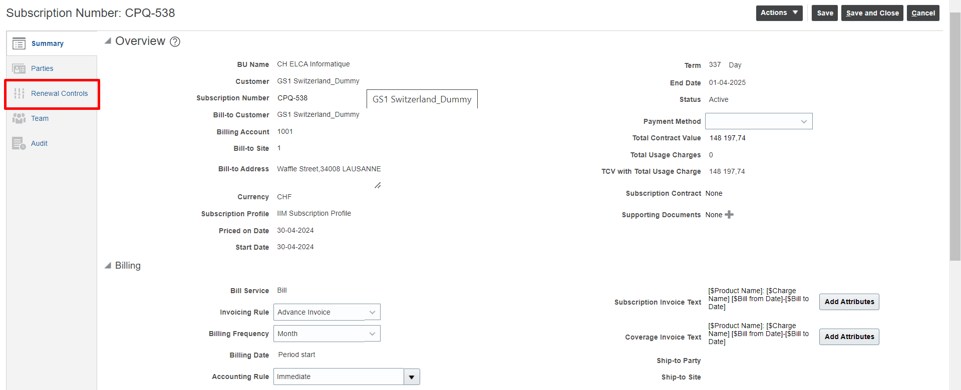

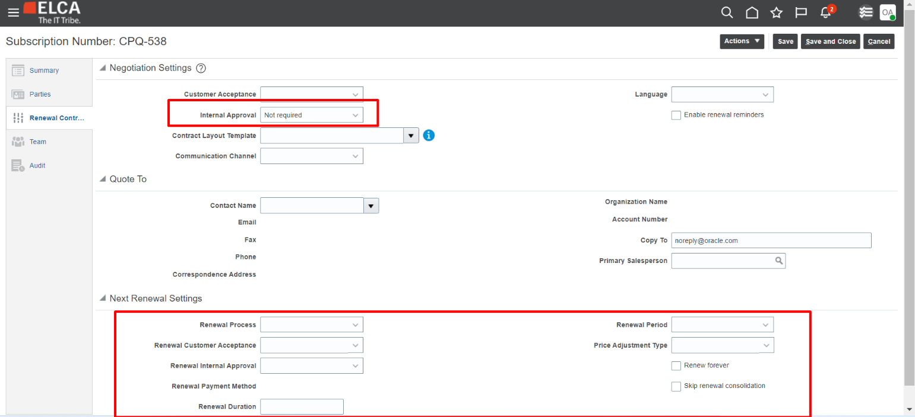

As highlighted above, “Internal Approval” is utilized if an Approval workflow is required to activate the subscription, or Not Required. As a default, this option has been set to “Not Required”.

The important fields for Renewal below are Renewal Process (Automatic, Manual or Do Not Renew), Renewal Customer Acceptance (Required or Not Required), Renewal Internal Approval (Required or Not Required), Renewal Duration and Renewal Period (Month, Quarter, Year).